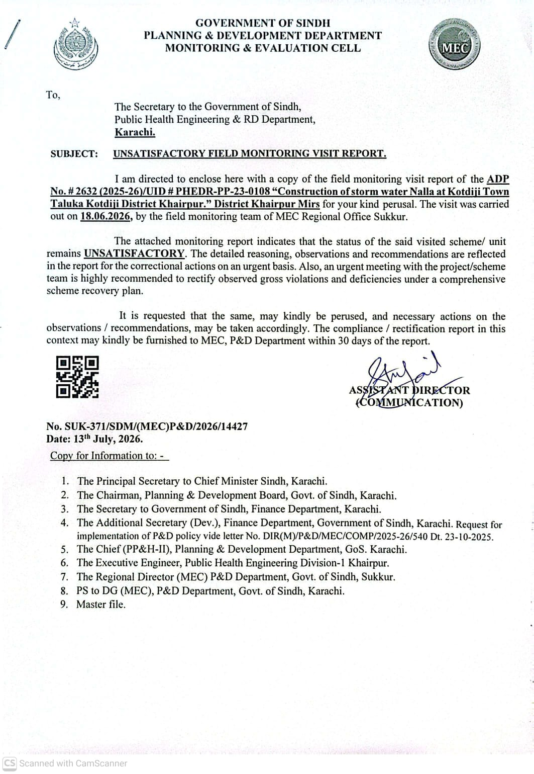
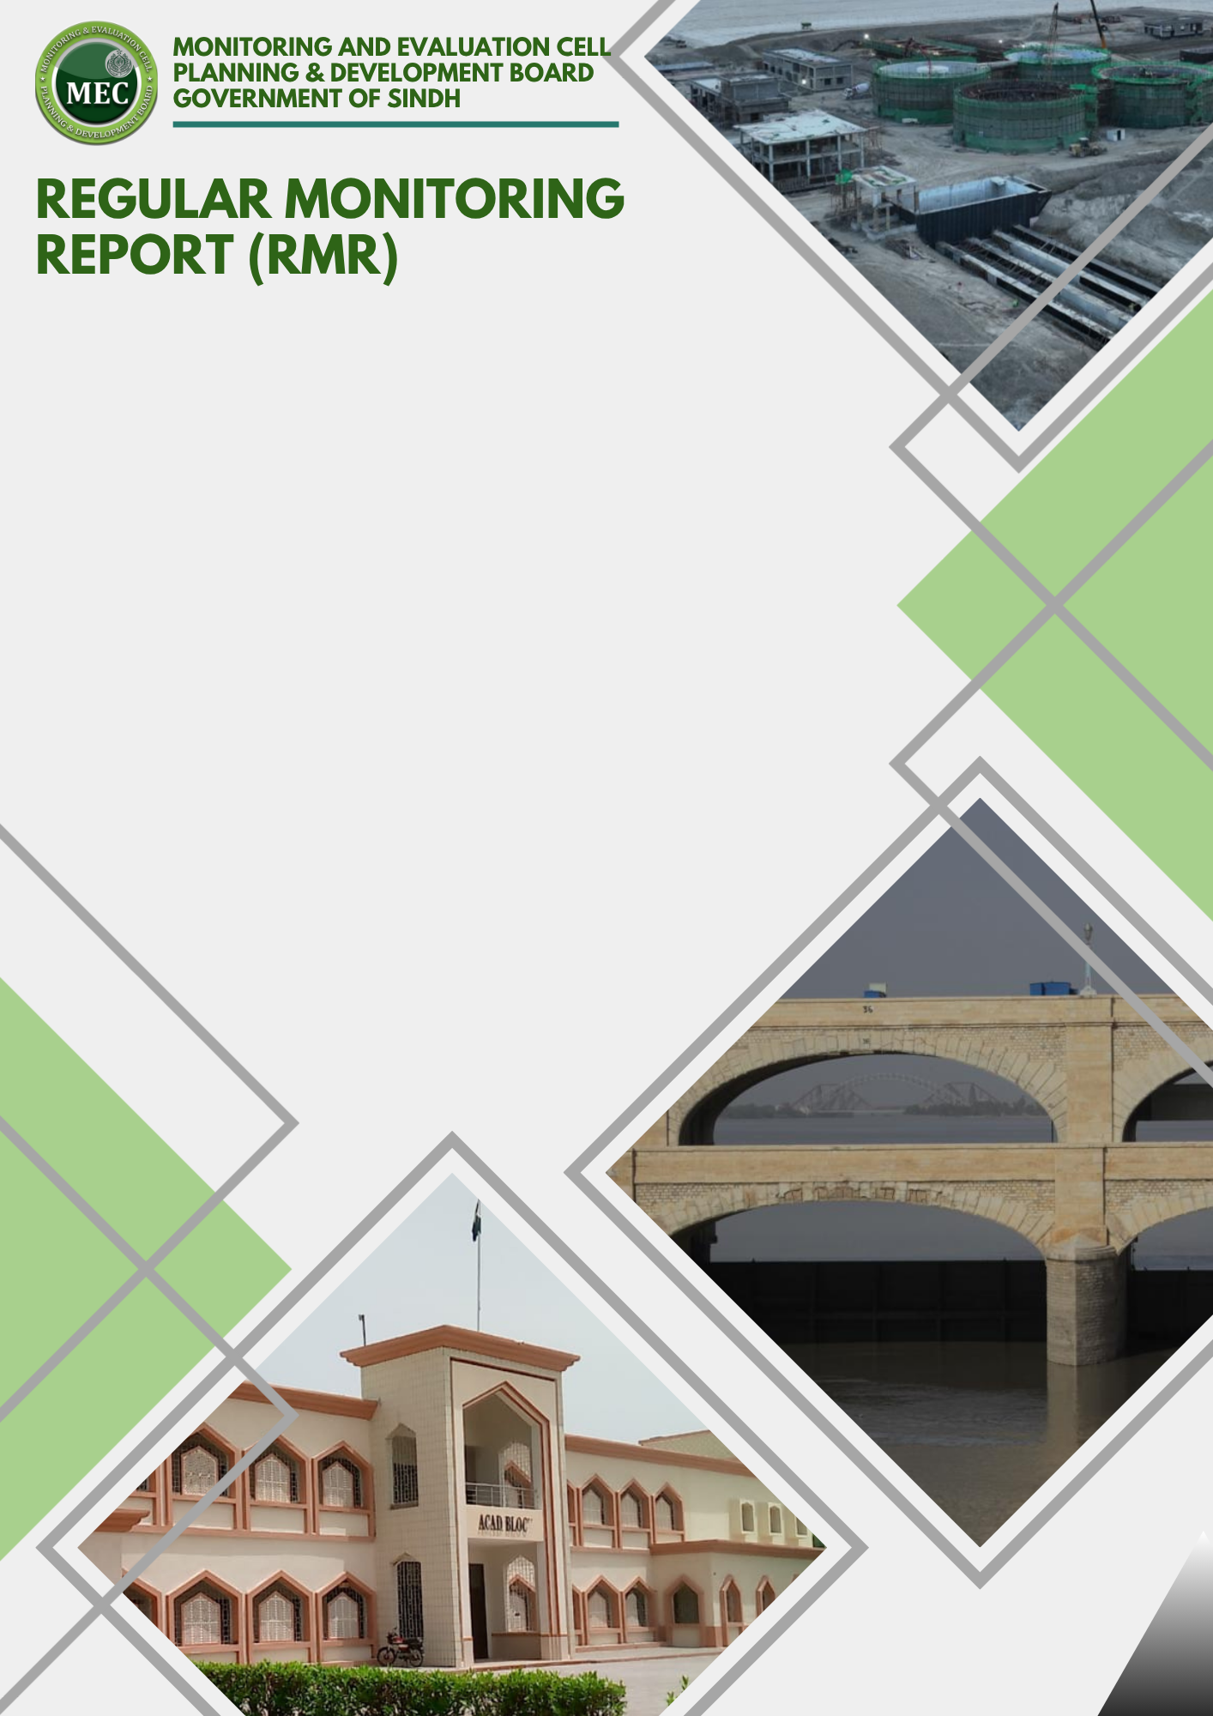
Physical Progress % | : | 75%%
Financial Progress % | : | 99.30% say 100%
Earned Value | : | 186.7590
SPI | : | 0.75
CPI | : | 0.75

PROGRESS ASSESSMENT

MEC Region | : | SUKKUR
ADP # | : | 2632 (2025-26)
Estimated Cost | : | 249.00 (Million)
Sub Sector | : | WS/Drainage
Admin Department | : | PHE & RD Department
Executing Agency | : | XEN PHE KHP Division-I

REGULAR MONITORING REPORT (RMR)
WATER SUPPLY & DRAINAGE SECTOR
Sub-Sector: Water Supply/Drainage |  |  |  |  |  |  |  |  | Type of Scheme: (Independent)
PART - A: SCHEME PROFILE
1. | Scheme / Unit Information
 |  |  | ADP No. |  |  | ADP 2632/ 2025-26 |  |  |  |  | UID No. |  |  |  |  | PHEDR PP-23 0108
 |  |  | Name of the Scheme / QRC |  |  | Construction of storm water Nalla at Kotdiji Town Taluka Kotdiji District Khairpur. |  |  |  |  |  |  |  |  |  |  |  | 
 |  |  | Visit Location of the Scheme |  |  | UC/Town |  | Taluka Kotdiji |  |  |  |  |  |  | District |  | Khairpur Mirs
 |  |  | GPS Location Coordinates |  |  | Lat (N): |  | 27.350151 |  |  |  |  |  |  | Long (E): |  | 68.712047
 |  |  | Administrative Department |  |  | Public Health Engineering Department/ Government of Sindh
 |  |  | Executing Agency |  |  | Public Health Engineering Division-I Khairpur
 |  |  | Consultant / Design Engineer |  |  | --
 |  |  | Contractor (s) |  |  | M/s Nazir Construction Company, Government Contractor
 |  |  | Revision of PC-I Status |  |  | N/A |  |  |  |  |  | Date of Revision (if any) |  |  |  |  | N/A
 | k. |  | Scheme Objectives (as per PC-I) |  |  | RCC Nala, C/Tank, S/chamber, P/House, P/Machinery, C/Wall, Staff Quarter, PE Rising Main. Power Connection
2. |  | Procurement Process Details
 |  | a. |  | Date of A.A. Issued | 14-03-2024 |  |  |  |  | b. |  |  | Procurement Method |  |  |  |  |  | Manual/ E-Pads
 |  | c. |  | No. of bidders/Pre-Qualified Contractors | 3 |  |  |  |  | d. |  |  | Date of LOA/Work award |  |  |  |  |  | 23-05-2024
 |  | e. |  | Reason for delay (A.A vs LOA) | The delay between Administrative Approval (14-03-2024) and LOA issuance (23-05-2024) is approximately 70 days. This indicates a considerable time gap in processing procurement formalities after approval. The delay requires clarification to ensure transparency and adherence to procurement timelines.
 |  | f. |  | Final Bid Amount | 249.00 |  |  |  |  | g. |  |  | Variance of Bid Amount against PC-I / T.S Cost (%) |  |  |  |  |  | No Variance
Any other Mis-Procurement observed.
3. | Monitoring Visit History
 |  |  | Last Visit Date (if any) |  |  | 23.04.2025 |  |  |  |  | Last Visit’s Assessment Status |  |  |  |  |  | Satisfactory
 |  |  | Planned Visit Date |  |  | 18.06.2026 |  |  |  |  | Current Visit Date |  |  |  |  |  | 01.07.2026
 |  |  | Reason for Delay (if any) |  |  | EA busy in their official assignments
 |  |  | A.D/E.A Officer(s) during visit |  |  | Name | Mr. Raiz Phulphoto |  |  |  |  |  |  |  | Designation |  | Assistant Engineer
 |  |  | MEC Team During the Visit |  |  | Name | Mr.Kashif Anwar |  |  |  |  |  |  |  | Designation |  | SMEO
 |  |  | Community/Stakeholder feedback |  |  | The community/stakeholders expressed dissatisfaction with the current progress of the scheme. They requested that the remaining works be completed on priority before the onset of the rainy season and made fully functional at the earliest. Overall, there is a strong demand from the local population for timely completion and operationalization of the facility to avoid seasonal disruptions.
Remarks:
4. | Financial Progress (FP). (Amounts in PKR, million)
 |  |  | Funding Agency Share (%) |  |  | GoS Share |  | 100% |  |  | GoP Share |  |  | 0% |  |  | FPA Share |  |  | 0%
 |  |  | Approved Cost of the Scheme (M) |  |  | Capital |  | 249 |  |  | Revenue |  |  | --- |  |  | Total |  |  | 249
 |  |  | Revised Cost of the Scheme  (if any) |  |  | Capital |  | N/A |  |  | Revenue |  |  | N/A |  |  | Total |  |  | N/A
 |  |  | Unit Cost within the Scheme  (if applicable) |  |  | Capital |  | N/A |  |  | Revenue |  |  | N/A |  |  | Total |  |  | N/A
 |  |  | Financial Progress  (Up to 5 Years) of Scheme |  |  | Up to  2021-22 |  | 2022-23 |  |  | 2023-24 |  |  | 2024 -25 |  |  | 2025 -26 |  |  | TOTAL
 |  |  | - Allocation |  |  | 0 |  | 0 |  |  | 62.250 |  |  | 46.675 |  |  | 180.795 |  |  | 289.72
 |  |  | - Releases (as per F.D. Data) |  |  | 0 |  | 0 |  |  | 15.563 |  |  | 46.675 |  |  | 180.795 |  |  | 243.03
 |  |  | - Expenditure (as per F.D/E.A Data) |  |  | 0 |  | 0 |  |  | 14.375 |  |  | 44.955 |  |  | 187.950 |  |  | 247.27
 |  |  | Overall Financial Progress in % |  |  | 99.30% Say 100% |  |  |  |  | FP variance vs PP |  |  |  |  |  | -25%

5. | Financial/Physical Progress Graph. (Amounts in PKR, million)

PART - B: SCHEME ANALYSIS
1. | Quantitative Breakdown (Provided by EA and verified by MEO)
S# | Domain | Activity / Material | Name of the Test | Required | Achieved | GAP  (if any) | Unit | Standard | Remarks
 | Building & Road | Earth Work | Excavation |  |  |  | Cft
 | Building & Road | Earth Work | Back Fill |  |  |  | Cft
 | Building, Road & Hydraulic Structures | Compaction | FDT | 95% |  |  | % | AASHTO
 | Building, Road & Hydraulic Structures | N | Sieve Analysis |  |  |  |  | ASTM C- 136
 | Building, Road & Hydraulic Structures | N | Sp. Gravity | 2.6 > 2.7 |  |  |  | ASTM C-128
 | Building, Road & Hydraulic Structures | N | Water Absorption | 3% |  |  | % | BS 812-2
 | Building & Road | Cement Concrete | Slump Test | 80 > 150 |  |  | Mm | ASTM C 143
 | Building & Road | Cement Concrete | Temperature | 75 > 95 |  |  | ºF | ACI 305
 | Building & Road | Cement Concrete | Water-Cement Ratio | 0.45 (Max)
 | Building | Steel Rebar Gr-40 | Tensile Test | 40000 |  |  | Psi | ASTM A-615
 | Building | Steel Rebar Gr-60 | Tensile Test | 60000 |  |  | Psi | ASTM A-615
 | Reinforced CC | NDT | Schmidt Hammer Test | 30 > 50 |  |  | N/mm2 | ASTM C-39
 | Reinforced CC | DT | Core Cutter Test | 25000 |  |  | Psi | ASTM C-40
 | Reinforced CC | DT | Cube Compressive Strength | 25000 |  |  | Psi | ASTM C-41
 | Discrepancy in Dimension in / Quality of material against design parameters/Structure |  |  | N/A
 | Discrepancy/deficiency in quality test against approved PC-I / PEC standards |  |  | N/A

2. | Scheme Progress/Component-wise breakdown- (CAPITAL)
 | S# | Major Unit/Component as per PC-I | Physical/Financial Progress
 | S# | Major Unit/Component as per PC-I | Quantity as Per PC-I | Quantity as Per T.S | Total Cost | Payment as per MB | PP (%) | FP (%) | Variance Between PP & FP
 | 1 | RCC Nala 2’.5” | 3000 Rft: | 2877 Rft | 73.962 | 77.296 | 100% | 104% | 4% Excess
 | 2 | RCC Nala 3’.0” | 2747 Rft | 2190 Rft | 62.286 | 56.099 | 78% | 90% | -12%
 | 3 | RCC SUMP WELL 15' dia | 1 No. | 1 No. | 0.761 | 1.293 | 90% | 169% | -79%
 | 4 | SCREENING CHAMBER 10' dia | 1 No. | 1 No. | 0.452 | 0.892 | 90% | 197% | -107
 | 5 | PUMP HOUSE (12 x 16) | 1 No. | 1 No. | 1.246 | 2.433 | 80% | 195% | -115%
 | 6 | PUMPING MACHINERY 50 BHP | 3 sets | 3 sets | 24.078 | 24.078 | 0% | 100% | -100%
 | 7 | DIESEL GENERATOR 200 KVA | 1 set | 1 set
 | 8 | SUCTION DELIVERY | 3 Job | 3 Job | 1.514 | 1.753 | 0% | 113% | -113%
 | 9 | P.E RISING MAIN 32" DIA | 3557 Rft | 3150 Rft | 57.242 | 57.242 | 90% | 100% | -10%
 | 10 | STAFF QUARTER | 1 No. | 1 No. | 0.660 | 6.152 | 95% | 929% | -834%
 | 11 | COMPOUND WALL | 500 Rft | 488 Rft | 2.194 | 8.204 | 95% | 383% | -288%
 | 16 | Land Acquisition | 0.50 Acr | Provision | 0.00 | 1.00 | --------- | --------- | ---------
 | 17 | External Electrification | 1 Job | Provision | 0.00 | 2.145 | --------- | --------- | ---------
 |  | Physical contingence | Provision | Provision | 0.00 | 0.00 | --------- | --------- | ---------
 |  | Difference Cost of Material | Provision | Provision | 0.00 | 0.00 | --------- | --------- | ---------
 |  | Price Contingencies | Provision | Provision | 0.00 | 0.00 | --------- | --------- | ---------
 |  | T.P.V 1% | Provision | Provision | 0.00 | 0.00 | --------- | --------- | ---------
 |  | SRB 5% | Provision | Provision | 11.220 | 8.685 | --------- | --------- | ---------
 | TOTAL |  | TOTAL | --- | 235.616 | 247.272

PART - C: QUALITY MANAGEMENT
Note: Addition of other relevant checks/tests may be included by initiating MEO in the following tables as per the type of structure/scheme.

1. | General Check
Domain |  | Activity / Material | Name of the Test | Readings Actual at Site (YES/NO) | Found in # of Places | Standard | Remarks  ( + / - )
Buildings / Roads / Bridges / Underpasses / Irrigation Banks |  | Observed Defects | Honey Combing | N0 | --- | IS | +
 |  | Observed Defects | Visible Cracks | N0 | --- | IS | +
 |  | Observed Defects | Misalignment | N0 | --- | IS | +
 |  | Observed Defects | Salinity | N0 | --- | IS | +
 |  | Observed Defects | Seepage | N0 | --- | IS | +
 |  | Observed Defects | Uneven Plaster | N0 | --- | IS | +
 |  | Observed Defects | Dumped Rusted Steel |  | Quantity in Tons | IS

Stage-Wise Observed Checklist for Irrigation/PHED Schemes/Dams
(Only Fill in the Relevant Items Based on the Visit Made)
Item # | Items | As per approved design | Remarks
1 | Excavation for drainpipes | Yes
3 | Pipe Laying | Yes
4 | Backfilling | Yes
5 | Internal and External Drains/RCC Nala | Yes
6 | CC blocks | No
7 | Screening chambers | Yes
8 | Collection tanks | Yes
9 | Septic tanks | No
10 | Pump House | Yes
11 | Pump House machinery available (i.e. pumping machines, chlorination and other items) | No
12 | Oxidation ponds/Sewage treatment plants | No
13 | Electrification works for pumps found | No | Partially supplied at disposal works not yet energized
14 | Back Supply (Generator/Solar) Found | No
15 | Lining Layout | NA
16 | Channel Lining | NA

3. | Misc. Checks/Compliances
Item # |  | Items | Check  (Yes/No) | Observation
 |  | Environmental & Social Safeguards (ESS) being followed | Yes
 |  | Labour / Workforce & Health, Safety & Environment (HSE) Compliance | Yes
 |  | Gender & Social Inclusion (GESI) Compliance | Yes
 |  | Climate Resilience & Disaster Risk Assessment | Yes

PART - D: DOCUMENTS
1. | Scheme Approval Documents (Provided by E/A)
Item # |  | Items | Availability  (Yes/No) | Observation
 |  | PC-I / PC-II (If framed) | Yes
 |  | Administrative Approval (AA) | Yes
 |  | Bid Evaluation Report (BER) | Yes
 |  | LOA/Work Order Issued to contractor(s) | Yes
 |  | Technical Sanction (TS) | Yes
 |  | Construction / Architecture Drawings | Yes
 |  | SEPA EIA/EA/NOC | N/A
 |  | Any Other Document ( _________________ ) | N/A

2. | Scheme Implementation Documents (Provided by E/A)
Item # |  |  | Items |  | Check  (Yes/No) |  | Observation
 |  |  | Implementation Schedule / Annual Work Plan (As per RBM) |  | Yes
 |  |  | Measurement Book (MB) |  | Yes
 |  |  | Soil investigation report |  | NA
PART - E: MONITORING ANALYSIS/ASSESSMENTS
1. |  | Earned Value Analysis
S# |  | Items |  | Result |  | Remarks
 |  | Planned Value or BCWS |  | 249.00 |  | Budgeted Cost of Work Scheduled
 |  | Earned Value or BCWP |  | 186.750 |  | Budgeted Cost of Work Performed
 |  | Actual Cost of Work Performed (ACWP) |  | 247.27 |  | Current Financial Progress
 |  | Schedule Performance Index (SPI) |  | 0.75 |  | SPI < 1.0: The Scheme is behind schedule, completing less work than planned.
 |  | Cost Performance Index (CPI) |  | 0.75 |  | CPI < 1.0: The Scheme is over budget, spending more than planned.

2. | Risk-Rated Observation Matrix
 | Field Officer | Category | Observation | Risk | Recommendation | Compliance Deadline
 | MEO/ SMEO | Physical | - There is a clear gap between physical progress and financial progress in the scheme, especially in RCC Nala (2’-5”) and RCC Nala (3’-0”).  - In RCC Nala (3’-0”), a shortfall of around 200 Rft was observed compared to the approved/executed quantities.  - Despite this shortfall, the financial progress does not match the actual work done on ground, which raises concerns about measurement accuracy.  - The RCC Nala (2’-5”) also shows variations between approved quantities and actual execution, indicating weak quantity control.  - At site, the Staff Quarter shows a noticeable mismatch between work done and the payments recorded.  - The Pump House (12’ x 16’) appears financially more advanced than its actual physical progress on ground.  - The Screening Chamber (10’ dia) also reflects higher financial booking compared to visible completed work.  - The Sump Well (15’ dia) work is still incomplete at site, as concrete pouring remains pending up to the design depth (approximately GFT level), indicating delayed execution and lack of full compliance with approved design requirements.  - The Pumping Machinery (50 BHP, 3 sets) has been fully paid, but no proper installation or working condition was observed at site.  - The Diesel Generator (200 KVA) was not found fully installed or operationally verified during the visit.  - The Suction and Delivery works (3 jobs) show financial progress, but physical completion at site is not clearly matching.  - The P.E Rising Main (32” dia) shows differences between planned quantities and what has actually been laid on ground.  - The Compound Wall (500 Rft) also reflects variation between approved quantity and executed work.  - Overall, multiple components including RCC Nala, Pump House, and machinery items show weak alignment between execution and payment.  - The overall impression is that site supervision, measurement verification, and QA/QC controls are not being properly enforced, leading to inconsistencies in work and payments. | High | - As the rainy season is approaching as per weather forecast, the remaining works should be completed on an expedited basis in accordance with approved design and specifications, and the scheme should be made fully functional and operational at the earliest to avoid further delays, damage, or disruption. Proper testing, commissioning, and handover should be ensured immediately after completion of all pending works.  - Due to high variation between approved and executed quantities in major items of the scheme, a proper Variation Order (VO) should be prepared, justified, and approved as per departmental rules, ensuring that all deviations are technically verified, duly recorded in the Measurement Book (MB), and regularized through competent authority before final settlement of payments | 01 Month
 | SMEO/MEO | Financial | 1. The scheme shows near 100% financial progress (99.30%) against only 75% physical progress, indicating a significant gap between expenditure and actual execution on ground. | Medium | It is recommended that a physical verification of all executed works be carried out to reconcile the gap between financial and physical progress. | 01 Month
 | SMEO/MEO | EVM | 2. The Earned Value Analysis indicates that the scheme is behind schedule (SPI = 0.75) and over budget (CPI = 0.75), reflecting alignment between planned and actual performance. The earned value is significantly lower than actual expenditure, showing inefficient utilization of funds against physical progress achieved. Overall, the results point to weak project management, cost control, and execution efficiency, requiring immediate corrective measures. | Medium | It is recommended that the execution plan be revised and accelerated to improve physical progress in line with the approved schedule. Strict cost control measures and monitoring of expenditure against actual achieved work (BCWP) should be enforced to eliminate inefficiencies. It is further recommended that regular Earned Value Analysis be conducted at site level to ensure timely corrective actions and improved project performance. | 01 Month
 | RD | Physical/Financial/EVM/PC-I Compliance/PM Arrangements/General/Procurement etc. | Observations and recommendations are based solely on the report of the visiting officer, as no personal site visit was conducted.  PHYSICAL:  Significant discrepancies were observed between the reported financial and physical progress of the scheme. Shortfalls in quantities, incomplete civil works, and unverified mechanical installations indicate weak measurement verification, inadequate QA/QC, and insufficient site supervision. Immediate verification of executed quantities, payments, and remaining works is required to ensure compliance with the approved scope and specifications.  FINANCIAL:  The scheme exhibits a significant mismatch between 99.30% financial progress and 75% physical progress, indicating that expenditure has outpaced the actual execution of works.  EVM/PC-1:  The EVM analysis indicates that the scheme is behind schedule (SPI = 0.75) and over budget (CPI = 0.75), with actual expenditure exceeding the earned value. This reflects inefficient fund utilization and weak project execution, requiring immediate corrective measures to improve cost and schedule performance. | High | Verify all executed quantities, measurements, and payments before processing any further financial claims.  Complete the remaining civil, mechanical, and electrical works on priority to align physical progress with financial expenditure.  Strengthen site supervision and QA/QC to ensure compliance with approved drawings, specifications, and quantities.  Investigate the significant gap between financial and physical progress and take corrective action where required.  Prepare a recovery plan to improve schedule performance (SPI) and cost efficiency (CPI) and ensure timely completion of the scheme.
 | SDM | Physical/Financial/EVM/PC-I Compliance/PM Arrangements/General/Procurement etc. | - Based on desk review of the submitted report and available documentary/pictorial evidence only, the report has adequately highlighted significant discrepancies between physical and financial progress.  - The scheme has attained 99.30% financial progress against only 75% physical progress, resulting in a 25% gap, which is technically significant for a civil engineering project.  - Advance Payment reflected in report. The EA should justify, why advance payment was made? And How EA plans to complete the scope of remaining work (overlapped by Advance Payment)  - Earned Value Analysis further confirms unsatisfactory project performance with SPI = 0.75 and CPI = 0.75, indicating that the project is simultaneously behind schedule and over budget.  - Photographic evidence also corroborates that several critical components including pump house roofing, sump well, screening chamber, disposal works, electrical works and pumping machinery remain incomplete despite almost full financial expenditure.  - The report generally reflects actual field conditions; however, several technical inconsistencies, incomplete quality documentation and calculation anomalies require correction before final acceptance. | High | - EA is recommended to recover the advance payment from the contractor, and until completion of approved scope the Call deposit/performance security must not be returned to the contractor.  - Testing of completed RCC works, machinery installation and electrical components should be carried out before final completion.  - Remaining civil, mechanical and electrical works should be completed on priority before the rainy season and the scheme commissioned only after successful testing. | 1 Month

3. | FINAL ASSESSMENT OF THE PROJECT / SCHEME / UNIT
 | MEO/SMEO | RD | SDM
 | Un-Satisfactory | Un-Satisfactory | UNSATISFACTORY

PART - F: PICTORIAL OBSERVATIONS
S# | Specific Observations | Pictures | Pictures
1. | Satellite imaginary map of the scheme | 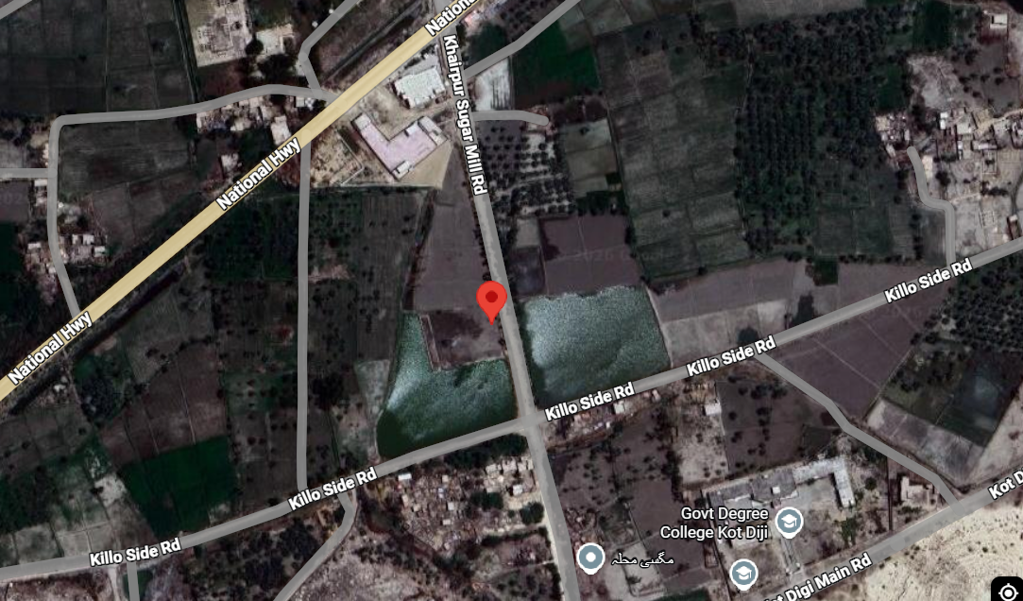
2. | Dimension verification of PE Rising main | 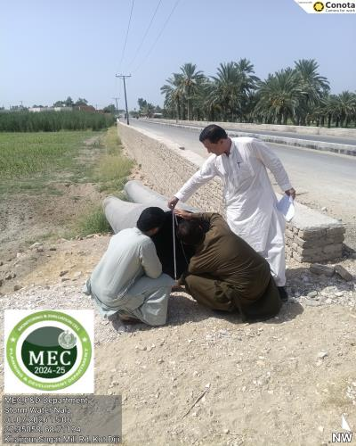 | 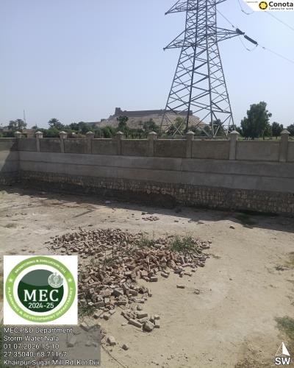
3. | Earth filling work for the disposal area is still remaining. | 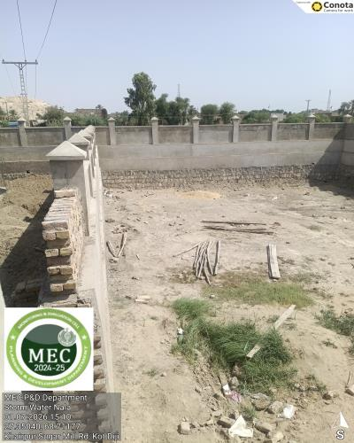 | 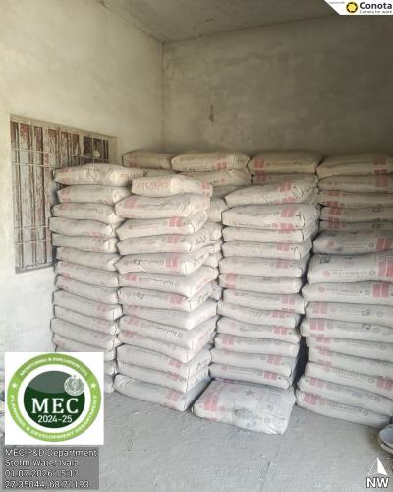
4. | View of the staff quarter and RCC sump well. Earthwork for the disposal works is in progress. | 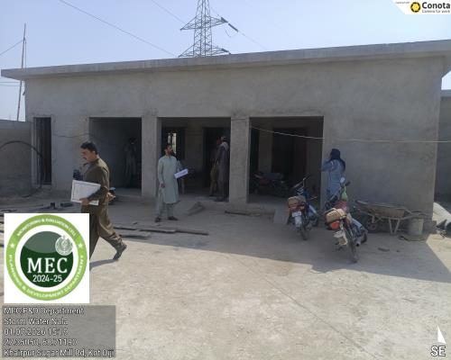 | 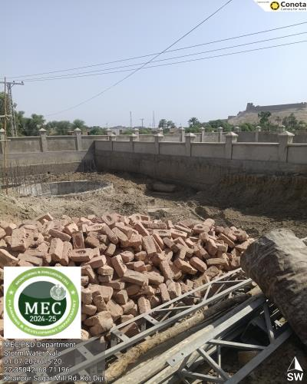
5. | View of the pump house roof slab. Concrete pouring for the roof slab is still remaining. | 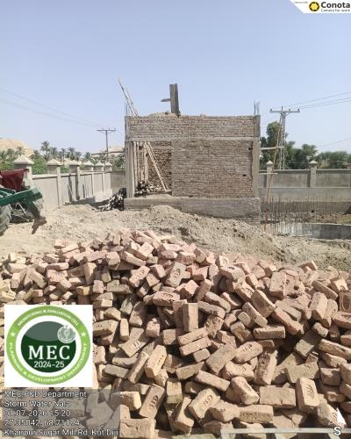 | 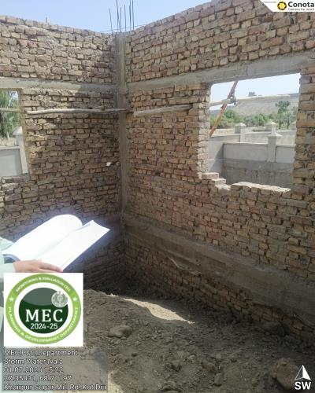
6. | Concrete pouring for the screening chamber is underway. Approximately 4 ft of pouring remains to achieve the final level. | 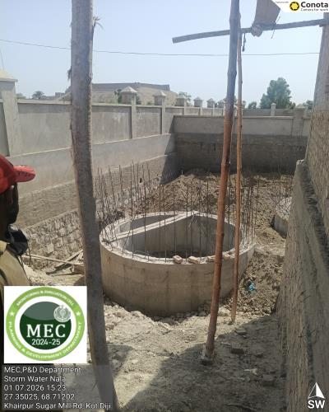 | 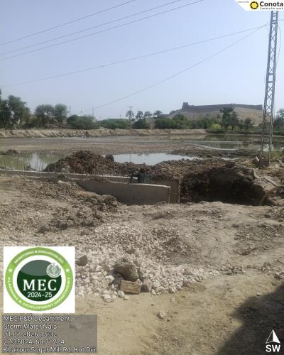
7. | Construction of the connecting section between the RCC nala and the disposal works is pending. | 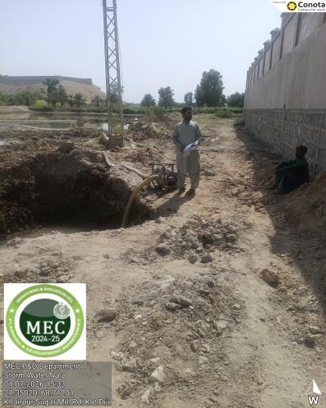 | 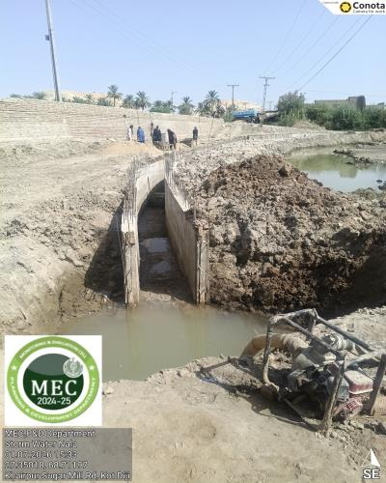
8. | Construction of the RCC covered nala is currently in progress. | 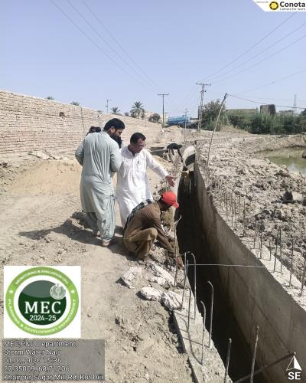 | 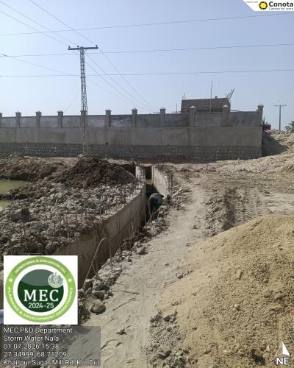
9. | The top slab finishing of the RCC nala was found satisfactory. | 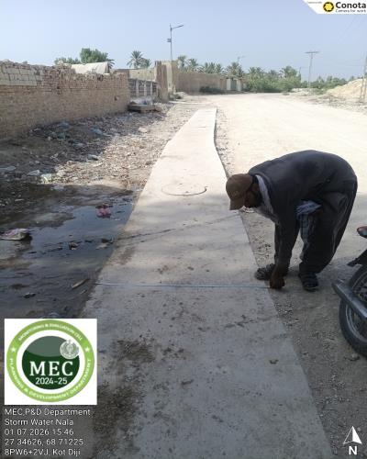 | 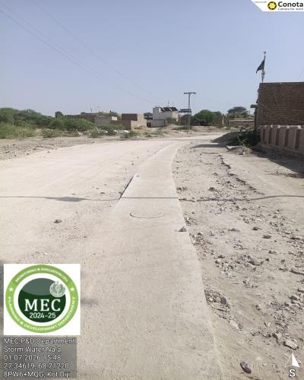
10. | View of the 2.5 ft RCC nala starting point from the IT Centre and the existing disposal works at Panjhati Colony. Improvement and extension of the disposal works are required. | 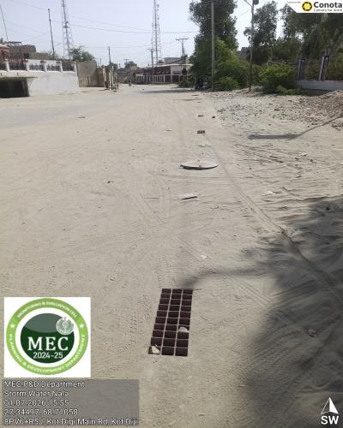 | 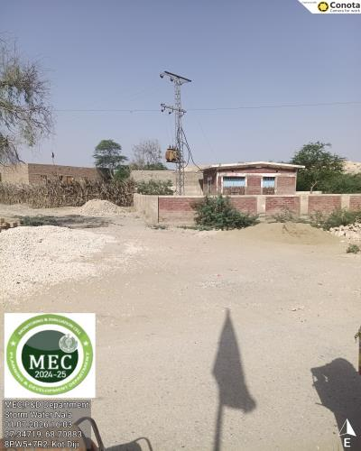
11. | The remaining section of the 3 ft wide RCC nala is to be connected to the existing pond in the city. | 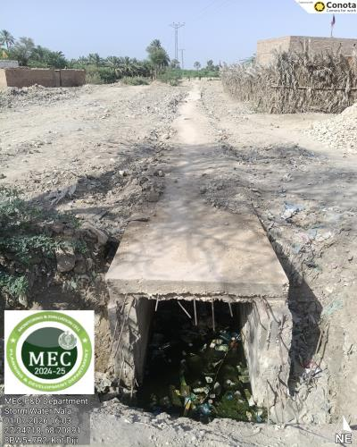 | 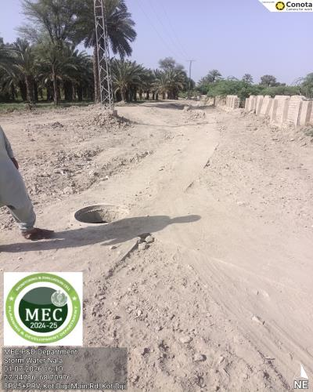
12. | View showing the connection of the 2.5 ft wide RCC nala discharging into the 3 ft wide RCC nala. | 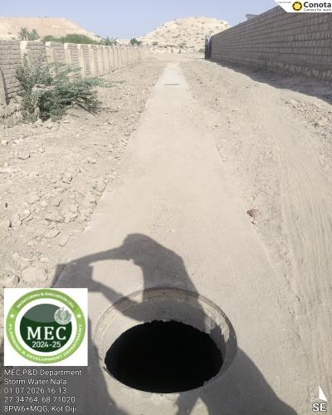 | 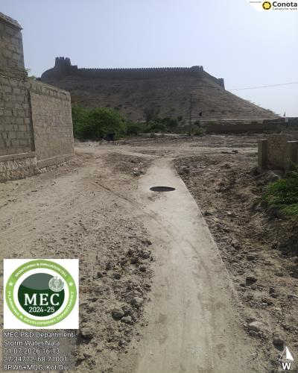
13. | External view of the newly constructed disposal works / pumping station. | 