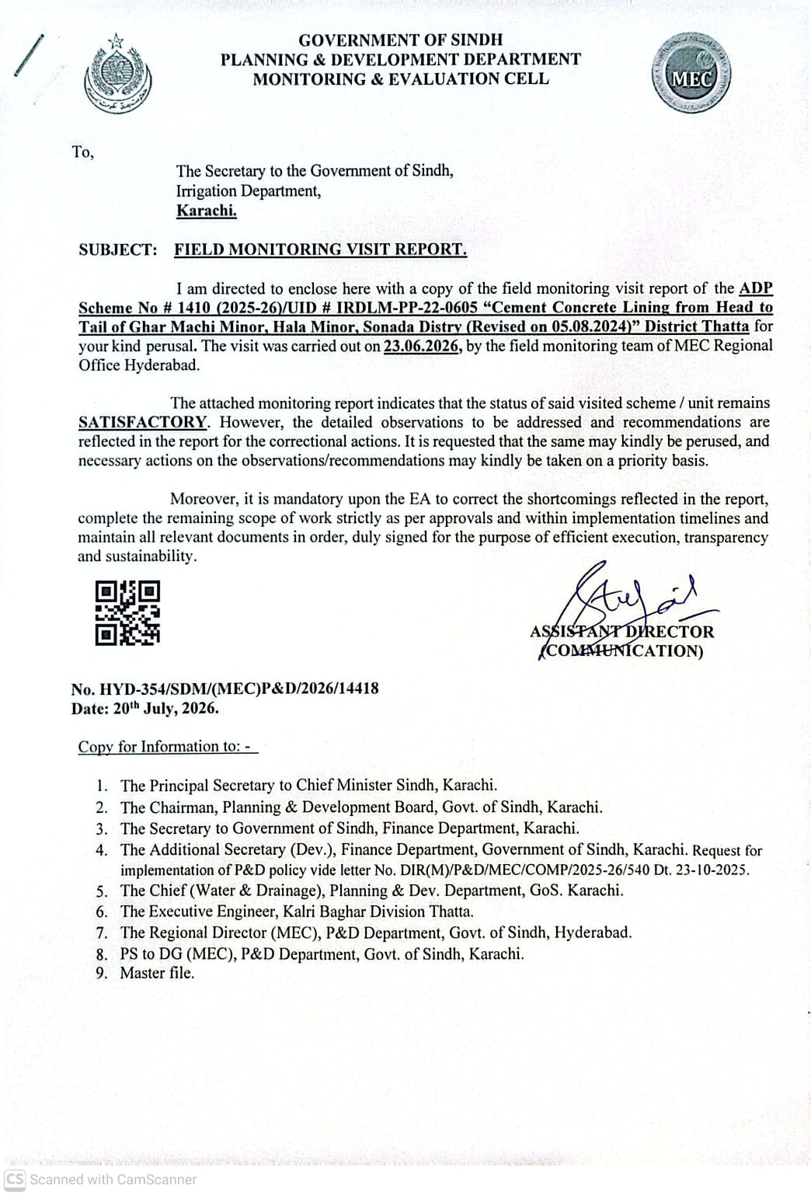
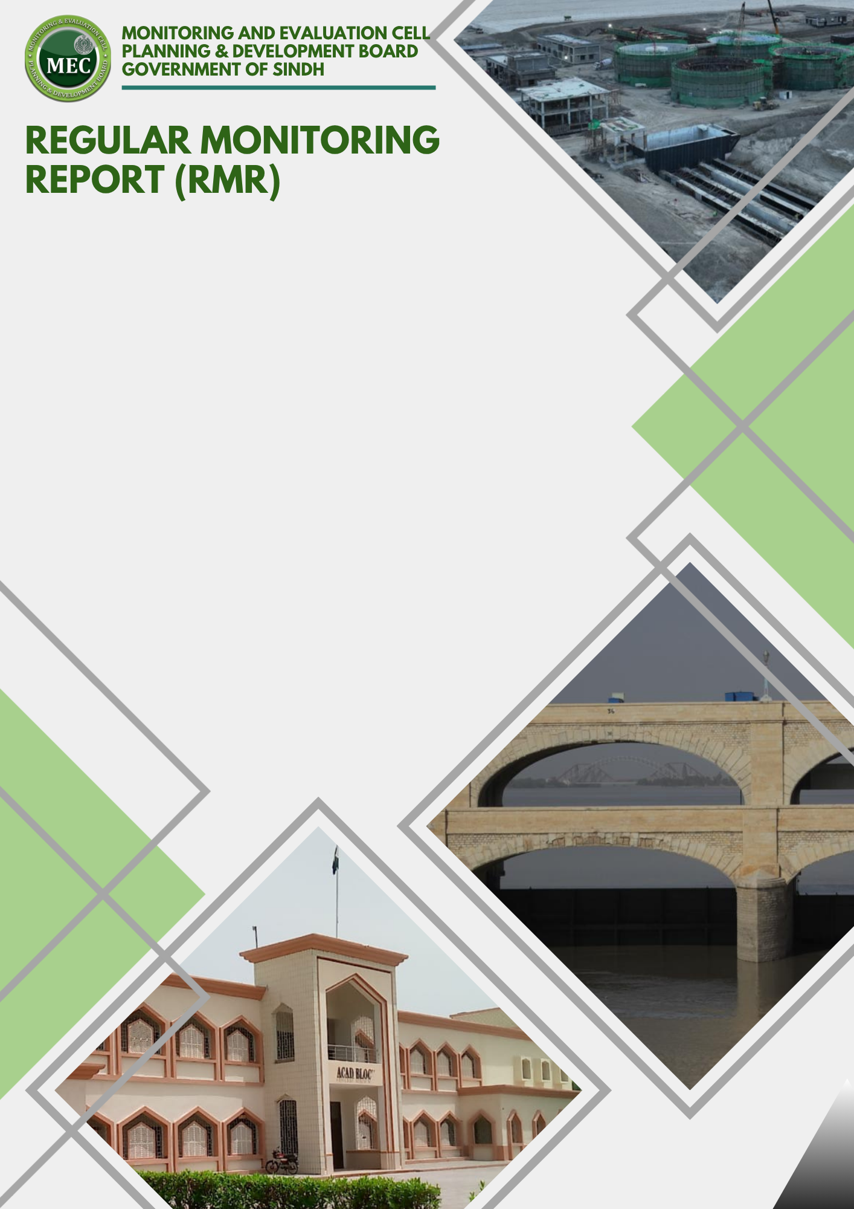
Physical Progress % | : | 75%
Financial Progress % | : | 72%
Earned Value | : | 551.867
SPI | : | 0.92
CPI | : | 1.05

PROGRESS ASSESSMENT

MEC Region | : | Hyderabad
ADP # | : | 1410
Estimated Cost | : | 735.823
Sub Sector | : | Lining Canals
Admin Department | : | Irrigation
Executing Agency | : | Kalri Baghar Division Thatta

REGULAR MONITORING REPORT (RMR)
INFRASTRUCTURE SECTOR
Sub-Sector : Lining canals |  |  |  |  |  |  |  |  | Type of Scheme : (Independent)
PART - A: SCHEME PROFILE
1. | Scheme / Unit Information
 |  |  | ADP No. |  |  | 1410(2025-26) |  |  |  |  | UID No. |  |  |  |  | IRDLM-PP-22-0605
 |  |  | Name of the Scheme / QRC |  |  | C.C. Lining from Head to Tail of Ghar Machi Minor, Hala Minor & Sonda Distry. |  |  |  |  |  |  |  |  |  |  |  | 
 |  |  | Visit Location of the Scheme |  |  | UC/Town |  | Thatta / Sonda |  |  |  |  |  |  | District |  | Thatta
 |  |  | GPS Location Coordinates |  |  | Lat (N): |  | 24.982629  24.660531 |  |  |  |  |  |  | Long (E): |  | 68.133536  67.909271
 |  |  | Administrative Department |  |  | Irrigation Department Government of Sindh
 |  |  | Executing Agency |  |  | Kalri Baghar Division Thatta
 |  |  | Consultant / Design Engineer |  |  | NA
 |  |  | Contractor (s) |  |  | M/s Hamlet Builders – M/s M.Z Enterprises (JV)
 |  |  | Revision of PC-I Status |  |  | Revised |  |  |  |  |  | Date of Revision (if any) |  |  |  |  | 12-09-2024
 | k. |  | Scheme Objectives (as per PC-I) |  |  | C.C. Lining from Head to Tail of Ghar Machi Minor, Hala Minor & Sonda Distry.
2. |  | Procurement Process Details
 |  | a. |  | Date of A.A. Issued | 14-04-2022 |  |  |  |  | b. |  |  | Procurement Method |  |  |  |  |  | Manual
 |  | c. |  | No. of bidders/Pre-Qualified Contractors | 01 |  |  |  |  | d. |  |  | Date of LOA/Work award |  |  |  |  |  | 10-06-2022
 |  | e. |  | Reason for delay (A.A vs LOA) | -
 |  | f. |  | Final Bid Amount | 728.940 |  |  |  |  | g. |  |  | Variance of Bid Amount against PC-I / T.S Cost (%) |  |  |  |  |  | -0.94%
3. | Monitoring Visit History
 |  |  | Last Visit Date (if any) |  |  | NA |  |  |  |  | Last Visit’s Assessment Status |  |  |  |  |  | NA
 |  |  | Planned Visit Date |  |  | 23/06/2026 |  |  |  |  | Current Visit Date |  |  |  |  |  | 22/06/2026 &23/06/2026
 |  |  | Reason for Delay (if any) |  |  | NA
 |  |  | A.D/E.A Officer(s) during visit |  |  | Name | Mr. M Ali Memon & Mr. Sataar Baharani |  |  |  |  |  |  |  | Designation |  | AEN Kalri Baghar Division Thatta
 |  |  | MEC Team During the Visit |  |  | Name | Engr Abdul Qayoom |  |  |  |  |  |  |  | Designation |  | MEO Hyderabad Region
 |  |  | Community/Stakeholder feedback |  |  | -
Remarks:
4. | Financial Progress (FP). (Amounts in PKR, million)
 |  |  | Funding Agency Share (%) |  |  | GoS Share |  | 100% |  |  | GoP Share |  |  | - |  |  | FPA Share |  |  | -
 |  |  | Approved Cost of the Scheme (M) |  |  | Capital |  | 414.892 |  |  | Revenue |  |  | - |  |  | Total |  |  | 414.892
 |  |  | Revised Cost of the Scheme  (if any) |  |  | Capital |  | 735.823 |  |  | Revenue |  |  | - |  |  | Total |  |  | 735.823
 |  |  | Unit Cost within the Scheme  (if applicable) |  |  | Capital |  | - |  |  | Revenue |  |  | - |  |  | Total |  |  | -
 |  |  | Financial Progress  (Up to 5 Years) of Scheme |  |  | Up to  2021-22 |  | 2022-23 |  |  | 2023-24 |  |  | 2024 -25 |  |  | 2025 -26 |  |  | TOTAL
 |  |  | - Allocation |  |  | 51.331 |  | 249.083 |  |  | 109.289 |  |  | 5.178 |  |  | 115.753 |  |  | 530.634
 |  |  | - Releases (as per F.D. Data) |  |  | 51.331 |  | 249.083 |  |  | 109.289 |  |  | - |  |  | 115.753 |  |  | 525.456
 |  |  | - Expenditure (as per F.D/E.A Data) |  |  | 51.331 |  | 249.083 |  |  | 109.289 |  |  | - |  |  | 115.753 |  |  | 525.456
 |  |  | Overall Financial Progress in % |  |  | 72% |  |  |  |  | FP variance vs PP |  |  |  |  |  | 3%

5. | Financial/Physical Progress Graph. (Amounts in PKR, million)

PART - B: SCHEME ANALYSIS
1. | Quantitative Breakdown (Provided by EA and verified by MEO)
S# | Domain | Activity / Material | Name of the Test | Required | Achieved | GAP  (if any) | Unit | Standard | Remarks
 | Building & Road | Earth Work | Excavation |  |  |  | Cft
 | Building & Road | Earth Work | Back Fill |  |  |  | Cft
 | Building, Road & Hydraulic Structures | Compaction | FDT | 95% |  |  | % | AASHTO
 | Building, Road & Hydraulic Structures | Soil | Sieve Analysis |  |  |  |  | ASTM C- 136
 | Building, Road & Hydraulic Structures | Soil | Sp. Gravity | 2.6 > 2.7 |  |  |  | ASTM C-128
 | Building, Road & Hydraulic Structures | Soil | Water Absorption | 3% |  |  | % | BS 812-2
 | Building & Road | Cement Concrete | Slump Test | 80 > 150 |  |  | Mm | ASTM C 143
 | Building & Road | Cement Concrete | Temperature | 75 > 95 |  |  | ºF | ACI 305
 | Building & Road | Cement Concrete | Water-Cement Ratio | 0.45 (Max)
 | Building | Steel Rebar Gr-40 | Tensile Test | 40000 |  |  | Psi | ASTM A-615
 | Building | Steel Rebar Gr-60 | Tensile Test | 60000 |  |  | Psi | ASTM A-615
 | Reinforced CC | NDT | Schmidt Hammer Test | 30 > 50 | 28,30,31 |  | N/mm2 | ASTM C-39 | Performed
 | Reinforced CC | DT | Core Cutter Test | 25000 |  |  | Psi | ASTM C-40
 | Reinforced CC | DT | Cube Compressive Strength | 25000 |  |  | Psi | ASTM C-41
 | Discrepancy in Dimension in / Quality of material against design parameters/Structure |  |  | NO
 | Discrepancy/deficiency in quality test against approved PC-I / PEC standards |  |  | NA  No test reports were submitted by EA

2. | Scheme Progress/Component-wise breakdown- (CAPITAL)
 | S# | Major Unit/Component as per PC-I | Physical/Financial Progress
 | S# | Major Unit/Component as per PC-I | Quantity as Per PC-I | Quantity as Per T.S |  | Total Cost | Payment as per MB | PP (%) | FP (%) | Variance Between PP & FP
 | Ghar Machi Minor
 |  | C.C Lining | 530069.75 Cft | 530069.75 Cft | 36,421,430 |  | 36,687,935 | 100.73% | 100.73% | 0%
 |  | Water Course | 35 Nos. | 35 Nos. | 68,928,133 |  | 0 | 0% | 0% | 0%
 |  | Road Bridges | 07 Nos. | 07 Nos. | 11,271,163 |  | 0 | 0% | 0% | 0%
 | Hala Minor
 |  | C.C Lining | 525880 Cft | 525880 Cft |  | 36,088,975 | 21,571,981 | 59.77% | 59.77% | 0%
 |  | Water Course | 18 Nos. | 18 Nos. |  | 37,777,936 | 38,923,545 | 103% | 103% | 0%
 |  | Road Bridges | 05 Nos. | 05 Nos. |  | 8,050,831 | 0 | 0% | 0% | 0%
 | Sonda Distry
 |  | C.C Lining | 1023508 Cft | 1023508 Cft |  | 70,234,226 | 67,159,357 | 95.62% | 95.62% | 0%
 |  | Water Course | 30 Nos. | 30 Nos. |  | 50,782,027 | 25,139,158 | 49.50% | 49.50% | 0%
 |  | Road Bridges | 12 Nos. | 12 Nos. |  | 19,321,989 | 4,596,400 | 50% | 25% | 25%
 |  | Regulator | 402.75 Sft | 402.75 Sft |  | 7,210,335 | 0 | 0% | 0% | 0%
 | TOTAL |  |  |  |  | 728.940 M | 525.4 M | 75% | 72% | 03%

PART - C: QUALITY MANAGEMENT
Note: Addition of other relevant checks/tests may be included by initiating MEO in the following tables as per the type of structure/scheme.

1. | General Check
Domain |  | Activity / Material | Name of the Test | Readings Actual at Site (YES/NO) | Found in # of Places | Standard | Remarks  ( + / - )
Buildings / Roads / Bridges / Underpasses / Irrigation Banks |  | Observed Defects | Honey Combing | NO | NO | IS | +
 |  | Observed Defects | Visible Cracks | NO | NO | IS | +
 |  | Observed Defects | Misalignment | NO | NO | IS | +
 |  | Observed Defects | Salinity | NO | NO | IS | +
 |  | Observed Defects | Seepage | NO | NO | IS | +
 |  | Observed Defects | Uneven Plaster | NO | NO | IS | +
 |  | Observed Defects | Uneven Tiling | NO | NO | IS | +
 |  | Observed Defects | Tor Steel used | NO | NO | IS | +
 |  | Observed Defects | Termite Found | NA | NA | IS | NA
 |  | Observed Defects | Low Quality Paint | NA | NA | IS | NA
 |  | Observed Defects | Dumped Rusted Steel | NA | Quantity in Tons | IS | NA
 |  |  |  |  | NA | IS | NA

Stage-Wise Observed Checklist for Irrigation Scheme
(Only Fill in the Relevant Items Based on the Visit Made)
Item # | Items | As per approved design | Remarks
1 | C.C Lining | Yes | CC lining Carried out at Ghar Machi minor, Hala Minor & Sonda Distry, the quality of visited work was found satisfactory
3 | Water Course | Yes | Water course work Carried out at Ghar Machi minor, Hala Minor & Sonda Distry, the quality of visited work was found satisfactory
4 | Road Bridges | Yes | Road Bridgework Carried out at Ghar Machi minor, Hala Minor & Sonda Distry, the quality of visited work was found satisfactory
5 | Regulator | No | Regulator repair work carried out at Sonda Distry however the regulator of Ghar Machi Minor was no started at site.
6 | CC blocks | NA
7 | Screening chambers | NA
8 | Collection tanks | NA
9 | Septic tanks | NA
17 | Stone pitching (Profile/Measurement/Interlocking/Grouting) | NA
20 | Inspection and Testing Reports Provided by E/A | NO

3. | Misc. Checks/Compliances
Item # |  | Items | Check  (Yes/No) | Observation
 |  | Environmental & Social Safeguards (ESS) being followed | Yes
 |  | Labour / Workforce & Health, Safety & Environment (HSE) Compliance | NA | Not checked as during visit no construction activity was in progress
 |  | Gender & Social Inclusion (GESI) Compliance | Yes
 |  | Climate Resilience & Disaster Risk Assessment | Yes

PART - D: DOCUMENTS
1. | Scheme Approval Documents (Provided by E/A)
Item # |  | Items | Availability  (Yes/No) | Observation
 |  | PC-I | Yes | PC1 submitted in soft.
 |  | Administrative Approval (AA) | Yes | Submitted in soft.
 |  | Bid Evaluation Report (BER) | Yes | Submitted in soft.
 |  | LOA/Work Order Issued to contractor(s) | Yes | Submitted in soft.
 |  | Technical Sanction (TS) | Yes | Submitted in soft.
 |  | Construction / Architecture Drawings | Yes | Available at site during visit
 |  | SEPA EIA/EA/NOC | NA
 |  | Any Other Document ( Test reports ) | NO

2. | Scheme Implementation Documents (Provided by E/A)
Item # |  |  | Items |  | Check  (Yes/No) |  | Observation
 |  |  | Implementation Schedule / Annual Work Plan (As per RBM) |  | Yes |  | Fetched from PC1
 |  |  | Measurement Book (MB) |  | Yes |  | Submitted in soft last RA
 |  |  | Soil investigation report |  | NA
PART - E: MONITORING ANALYSIS/ASSESSMENTS
1. |  | Earned Value Analysis
S# |  | Items |  | Result |  | Remarks
 |  | Planned Value or BCWS |  | 600 |  | Budgeted Cost of Work Scheduled
 |  | Earned Value or BCWP |  | 551.867 |  | Budgeted Cost of Work Performed
 |  | Actual Cost of Work Performed (ACWP) |  | 525.456 |  | Current Financial Progress
 |  | Schedule Performance Index (SPI) |  | 0.92 |  | SPI = 1.0: The Scheme is exactly on schedule.  SPI > 1.0: The Scheme is ahead of schedule, completing more work than planned.  SPI < 1.0: The Scheme is behind schedule, completing less work than planned.
 |  | Cost Performance Index (CPI) |  | 1.05 |  | CPI > 1.0: The Scheme is under budget and performing efficiently.  CPI = 1.0: The Scheme is exactly on budget.  CPI < 1.0: The Scheme is over budget, spending more than planned.

2. | Risk-Rated Observation Matrix
 | Field Officer | Category | Observation | Risk | Recommendation | Compliance Deadline
 | MEO | Physical | CC Lining Ghar Machi Minor 00RD to 20.00RDs:  During field Monitoring visit conducted by the Monitoring and Evaluation Cell (MEC) team at the Ghar Machi Minor, located near the Thatta-Sujawal Road, several key physical and financial observations were documented. The monitoring visit specifically focused on the reach from RD-00 to RD-20, where the Cement Concrete (CC) lining work was found to be successfully completed. To assess the structural integrity of the lining, the team carried out random Non-Destructive Testing (NDT) using a Schmidt hammer, which yielded entirely satisfactory compressive strength results. While the overall earthwork, compaction, and leveling for both the Inspection Path (IP) and Non-Inspection Path (NIP) remain incomplete, the IP was notably clear and motor able within the specific sub-reach of RD-01 to RD-07. Conversely, critical headwork components have experienced delays, as construction has not yet commenced on the regular regulator at RD-00 of the Ghar Machi Minor at XRD-45 of the main KB Feeder.  During the site debriefing, the Executing Agency (EA) provided further context regarding the project's overall status, introducing a few discrepancies and highlighting the contractor's current financial position. The EA briefed that construction on 28 module (watercourse) outlets is already partially underway. Addressing the pending items, the EA assured the monitoring team that the remaining earthwork, compaction, leveling, and regulator construction would be mobilized and finalized in the near future. Crucially, the EA clarified the financial dynamics of the scheme, stating that the contractor has only received payments for the completed CC lining work. For all other ongoing project components, the contractor's physical progress slightly exceeds their financial progress, demonstrating that substantial work is being executed on-site ahead of official measurement and budgetary disbursement. | Low | since the contractor’s physical progress on secondary components—such as the 28 partially completed modules—currently exceeds their financial progress, the EA should expedite the verification, measurement, and processing of interim payment certificates for these components. Releasing these outstanding funds will maintain the contractor's cash flow, reward their proactive mobilization, and ensure that the momentum of the work is not disrupted.  Furthermore, a strict timeline must be enforced for the delayed head works, requiring the contractor to immediately submit a revised work schedule for the unstarted regulator at RD-00 of the Ghar Machi Minor at RD-45 of the KB Feeder. Because these regulators are critical for proper water control and safety, construction must begin before the next canal closure period or high-flow season to prevent operational bottlenecks. Finally, while the completed Cement Concrete (CC) lining demonstrated satisfactory compressive strength during random Schmidt hammer testing, the unfinished earthwork, compaction, and leveling on both the Inspection Path (IP) and Non-Inspection Path (NIP) pose a threat to the lining's long-term stability. The EA must direct the contractor to prioritize the backfilling, leveling, and mechanical compaction of the canal banks alongside the lining to protect the concrete shoulders from erosion and to ensure the entire reach becomes safely motorable. | 1 Month
 |  |  | CC Lining Hala Minor 00RD to 20.00RDs:  During the field Monitoring visit conducted by the Monitoring and Evaluation Cell (MEC) team at the Hala Minor, located near the Thatta-Sujawal KB Feeder Road, several key engineering and financial aspects of the project were documented. The monitoring visit focused on the reach from RD-00 to RD-20, where the Cement Concrete (CC) lining work was found to be completed and in satisfactory condition. To verify the structural quality of the concrete, random Non-Destructive Testing (NDT) using a Schmidt hammer was performed across various RDs, yielding entirely satisfactory compressive strength results. Furthermore, the top lip-to-lip width of the canal was physically verified at several spots and found to fully conform to the approved engineering design parameters. In terms of accessibility, the Inspection Path (IP) was motor able from RD-00 to RD-10, allowing the team to conduct a thorough evaluation of the reach. However, critical structural and earthwork components remain pending; no work has started on the Village Road Bridges (VRBs), and the earthwork, compaction, and leveling for both the IP and Non-Inspection Path (NIP) have not yet been carried out.  During the site briefing, the Executing Agency (EA) clarified that Hala Minor off-takes from the cross-regulator at RD-72 of the main KB Feeder, where key head works are located. Regarding the distribution structures, the EA reported that out of the total scope, work on 17 inlet modules (watercourses) is currently partially completed. Crucially, it was noted that these ongoing module works have been executed by the contractor without receiving any financial payment or disbursement to date, indicating that physical progress on these specific sub-components is running ahead of financial processing. Addressing the unexecuted portions of the project, the EA assured the monitoring team that the pending earthwork, compaction, and VRB construction would be mobilized and started at the site in the near future. | Low | First, while the completed Cement Concrete (CC) lining is in satisfactory condition and meets design specifications for lip-to-lip width, the total absence of earthwork, compaction, and leveling on both the Inspection Path (IP) and Non-Inspection Path (NIP) poses a serious risk to the canal's long-term stability. The Executing Agency (EA) must immediately direct the contractor to initiate mechanical compaction and backfilling along the lining shoulders to prevent hydrostatic pressure imbalances or bank erosion from undermining the newly laid concrete. Second, given that the contractor has demonstrated proactive mobilization by partially completing 17 inlet modules without receiving any financial disbursement, the EA should urgently process the measurement sheets and interim payment certificates for these structures. Releasing these justified funds will reinforce the contractor's cash flow and ensure they remain financially capable of executing the remaining scope without delays.  Furthermore, a strict engineering timeline must be established for the cross-drainage infrastructure, as no work has commenced on any Village Road Bridges (VRBs) despite the lining being complete up to RD-20. The EA must compel the contractor to submit a synchronized construction schedule for these bridges to prevent localized transportation bottlenecks for the community and to avoid damaging the finished lining during subsequent heavy machinery movement. Finally, because Hala Minor off-takes from the critical cross-regulator point at RD-72 of the main KB Feeder, a comprehensive joint inspection of the intake structure must be prioritized before the upcoming canal closure or high-flow season. This will ensure that water regulation into the completed reach can be safely managed in tandem with the newly built inlet modules. | 1 Month
 |  | Physical | CC Lining Distributary 00RD to 35.00RDs:  The Monitoring and Evaluation Committee (MEC) team conducted a site visit to inspect the cement concrete (CC) lining work at the Sonda Distributaries, covering a total completed length of 35 Reduced Distances (RDs). Due to the Inspection Path (IP) and Non-Inspection Path (NIP) being entirely non-motor able, the team was forced to inspect random spots along the channel. Quality assurance via Non-Destructive Testing (NDT) was performed at RD 01, RD 08, and RD 16 using a Schmidt hammer, which confirmed that the compressive strength of the CC lining complies with the project's specified design strength, yielding a "fair" overall quality rating. Additionally, minor repairs to the regulator at RD 00 of the Sonda Distributary (located at the X19.5 RD Link Canal) were found completed. However, critical deficiencies were observed as earthwork, compaction, and leveling on both the IP and NIP banks have not been carried out, and required de-weeding and jungle clearance remain uninitiated on several RDs. Addressing these gaps, the Executing Agency (EA) briefed the MEC team that the contractor has currently only received financial payments for the core CC lining work; consequently, the construction of various inlet structures across different RDs represents additional physical progress that currently exceeds the recorded financial disbursement. | Low | To ensure project sustainability and compliance, the Executing Agency (EA) must immediately direct the contractor to prioritize and execute the pending earthwork, mechanical compaction, and precision leveling along both the Inspection Path (IP) and Non-Inspection Path (NIP) to restore motor able access for future monitoring and operations. Immediate orders should also be issued to initiate comprehensive de-weeding and jungle clearance across all deficient Reduced Distances (RDs) to clear the hydraulic channel and protect the structural integrity of the newly completed CC lining. Furthermore, the EA should formally document and reconcile the additional physical progress achieved on the inlet structures against the current financial disbursements to update the project ledger accurately, while continuously monitoring the regulator at RD 00 to ensure that the executed minor repairs remain durable under active flow conditions. | 1 Month
 |  | Financial | The scheme Financial progress was72% & the Physical progress was 75%. |  | N/A | N/A
 |  | EVM | The Scheme is slightly behind schedule.The Scheme is under budget and performing efficiently. |  | N/A | N/A
 |  | PC-I Compliance | - Technical Compliance: Executed works were found to be in full compliance with PC-I and Technical Sanction (T.S.) specifications. | N/A | - Technical Compliance: All remaining work must be executed in strict accordance with the approved PC-I and Technical Sanction (T.S.) specifications. | N/A
 |  | Procurement | Procurement: The tendering process was executed in full compliance with SPPRA rules. All stages—including prequalification, bidding, and contract award—were conducted transparently and in accordance with regulatory procurement procedures. | N/A | - Documentation & Compliance: Maintain comprehensive documentation of the tendering process and ensure continuous monitoring to uphold SPPRA compliance throughout contract execution, including any subsequent variations or extensions. | N/A
 |  | General | The concrete lining on two Minors and one Distributary has been completed, the earthwork on the IP/NIP and the construction of a regulator on one Minor are yet to be initiated. The EA briefed the team that work on these remaining components will commence shortly, ensuring timely completion of the scheme, subject to the timely release of funds. | NA | The Executing Agency (EA) must immediately formulate a strict, fund-contingent timeline for the contractor to mobilize machinery and labor for the pending earthwork on the IP/NIP and the foundation work of the uninitiated regulator to prevent project stagnation despite the completed lining. To safeguard the project schedule, the EA should proactively coordinate with higher authorities to expedite the requisition and release of the remaining funds, while simultaneously monitoring the contractor to ensure that construction on these critical components commences immediately upon financial disbursement. | 1 Month
 | RD | Physical | Hala Minor (RD 00–20):  The Cement Concrete (CC) lining work from RD 00 to RD 20 was found completed, and the overall quality of the executed work was observed to be satisfactory .Random Schmidt Hammer NDT results confirmed acceptable concrete compressive strength, while the canal top lip-to-lip width was verified in accordance with the approved design. The Inspection Path (IP) was motor able up to RD 10; however, earthwork, compaction, leveling of the IP/NIP, and Village Road Bridge (VRB) construction have not yet commenced. The Executing Agency (EA) informed that Hala Minor off-takes from the KB Feeder cross-regulator at RD 72 and that 17 inlet modules are under construction without financial payment, indicating physical progress ahead of financial disbursement for these components.  Sonda Distributary:  The MEC team inspected the completed 35 RDs of CC lining through random accessible locations due to non-motorable IP/NIP. Schmidt Hammer NDT at selected RDs confirmed satisfactory concrete strength, and minor repairs to the regulator at RD 00 were found completed. However, earthwork, compaction, leveling of the IP/NIP, and de-weeding/jungle clearance remain pending. The EA stated that payments have been released only for the CC lining, while construction of inlet structures is in progress without corresponding financial disbursement, resulting in physical progress exceeding the recorded financial progress for these works. | Low | • Expedite the pending earthwork, compaction, and leveling of both the Inspection Path (IP) and Non-Inspection Path (NIP) to the approved specifications for safe access and long-term canal stability.  • Commence and complete the Village Road Bridges (VRBs) and remaining canal structures without delay to ensure uninterrupted public access and operational functionality.  • Complete all inlet modules/watercourses and associated structures in accordance with the approved drawings and technical specifications.  • Carry out de-weeding and jungle clearance along the canal banks before project completion to facilitate inspection, operation, and maintenance.  • Maintain strict quality control during the remaining works through regular field supervision, material testing, and compaction testing to ensure compliance with the approved standards.  • Synchronize physical execution with financial progress by promptly processing verified completed works and avoiding significant gaps between physical and financial achievements.
 | SDM | Physical/Financial/EVM/PC-I Compliance/PM Arrangements/General/Procurement etc. | - The submitted Regular Monitoring Report has been examined from engineering, contractual, financial and monitoring perspectives.  - The completed CC lining works generally exhibit acceptable workmanship and the random Schmidt Hammer Test results indicate satisfactory in-situ concrete strength.  - The physical and financial progress remain reasonably aligned and no indication of abnormal financial irregularity is evident from the available record.  - Nevertheless, several important components including regulators, Village Road Bridges (VRBs), earthwork, compaction, Inspection Path (IP), Non-Inspection Path (NIP), jungle clearance and remaining watercourse structures are still incomplete and require close monitoring to avoid schedule slippage.  - The absence of laboratory test reports and incomplete HSE assessment reduce the overall quality of technical documentation. | Low | The Executing Agency should ensure timely completion of the remaining works together with complete quality assurance documentation before final completion. EA shall:  - Provide complete laboratory quality control reports (Cube Strength, FDT, Aggregate Tests, Sieve Analysis, Water Absorption, etc.).  - Complete pending earthwork, compaction, Inspection Path (IP), Non-Inspection Path (NIP), regulators, watercourses and remaining bridge works on priority to avoid further schedule slippage.  - All Joints and Cracks to be filled with QUIKRETE® Advanced Polymer Concrete Crack Sealant or equivalent compound.  - All filled joints to be taped with Adhesive Tape such as Sikadur-Combiflex or equivalent.  - Interlocking of panels to be ensured (with no seepage).  - Slope profile to be ensured as per design with high velocity flow.  - Banks on both sides to be maintained (compaction and weed growth to be controlled). | 1 Month

3. | FINAL ASSESSMENT OF THE PROJECT / SCHEME / UNIT
 | MEO | RD | SDM
 | Satisfactory | Satisfactory | Satisfactory

PART - G: PICTORIAL OBSERVATIONS
Note: MEO to add only relevant pictures / corroborating major Scheme deficiencies/deviation, etc, and performance indicators/achievements.
S# | Specific Observations | Pictures
1. | CC Lining Ghar Machi Minor 00RD to 20.00RDs:  During field Monitoring visit conducted by the Monitoring and Evaluation Cell (MEC) team at the Ghar Machi Minor, located near the Thatta-Sujawal Road, several key physical and financial observations were documented. The monitoring visit specifically focused on the reach from RD-00 to RD-20, where the Cement Concrete (CC) lining work was found to be successfully completed. To assess the structural integrity of the lining, the team carried out random Non-Destructive Testing (NDT) using a Schmidt hammer, which yielded entirely satisfactory compressive strength results. In terms of cross-drainage structures, the team physically verified one completed Village Road Bridge (VRB) at the site. While the overall earthwork, compaction, and leveling for both the Inspection Path (IP) and Non-Inspection Path (NIP) remain incomplete, the IP was notably clear and motorable within the specific sub-reach of RD-01 to RD-07. Conversely, critical headwork components have experienced delays, as construction has not yet commenced on the regular regulator at RD-00 of the Ghar Machi Minor at XRD-45 of the main KB Feeder.  During the site debriefing, the Executing Agency (EA) provided further context regarding the project's overall status, introducing a few discrepancies and highlighting the contractor's current financial position. The EA briefed the team that two VRBs have actually been completed and that construction on 28 module (watercourse) outlets is already partially underway. Addressing the pending items, the EA assured the monitoring team that the remaining earthwork, compaction, leveling, and regulator construction would be mobilized and finalized in the near future. Crucially, the EA clarified the financial dynamics of the scheme, stating that the contractor has only received payments for the completed CC lining work. For all other ongoing project components, the contractor's physical progress actively exceeds their financial progress, demonstrating that substantial work is being executed on-site ahead of official measurement and budgetary disbursement. | 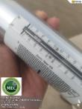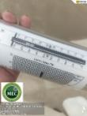 | 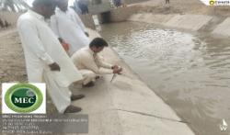
2. |  | 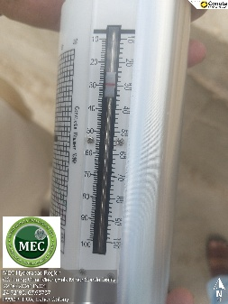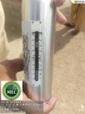 | 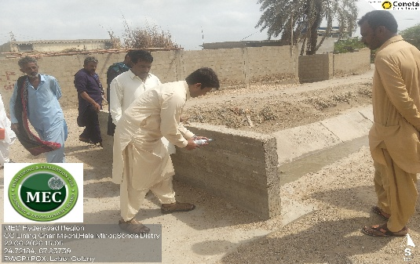
3. |  | 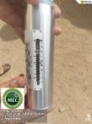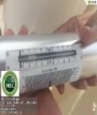 | 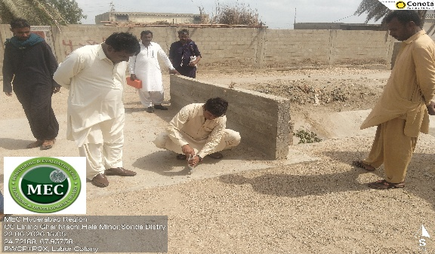
4. |  | 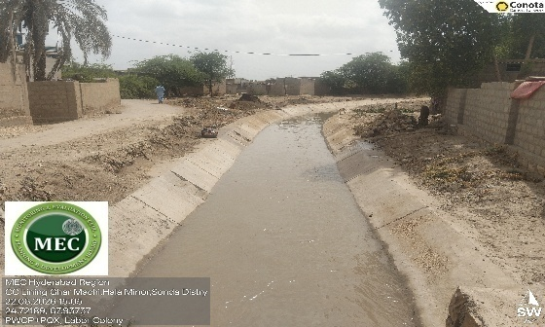  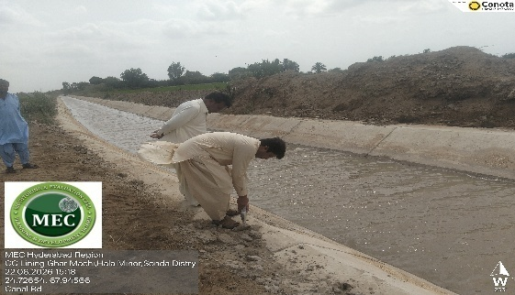 | 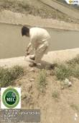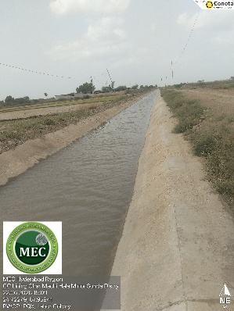  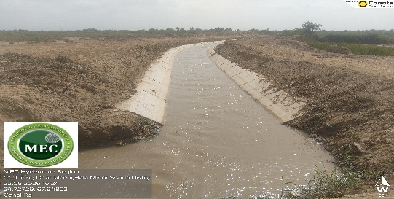
5. | CC Lining Hala Minor 00RD to 20.00RDs:  During the field Monitoring visit conducted by the Monitoring and Evaluation Cell (MEC) team at the Hala Minor, located near the Thatta-Sujawal KB Feeder Road, several key engineering and financial aspects of the project were documented. The monitoring visit focused on the reach from RD-00 to RD-20, where the Cement Concrete (CC) lining work was found to be completed and in satisfactory condition. To verify the structural quality of the concrete, random Non-Destructive Testing (NDT) using a Schmidt hammer was performed across various RDs, yielding entirely satisfactory compressive strength results. Furthermore, the top lip-to-lip width of the canal was physically verified at several spots and found to fully conform to the approved engineering design parameters. In terms of accessibility, the Inspection Path (IP) was motorable from RD-00 to RD-10, allowing the team to conduct a thorough evaluation of the reach. However, critical structural and earthwork components remain pending; no work has started on the Village Road Bridges (VRBs), and the earthwork, compaction, and leveling for both the IP and Non-Inspection Path (NIP) have not yet been carried out.  During the site briefing, the Executing Agency (EA) clarified that Hala Minor off-takes from the cross-regulator at RD-72 of the main KB Feeder, where key head works are located. Regarding the distribution structures, the EA reported that out of the total scope, work on 17 inlet modules (watercourses) is currently partially completed. Crucially, it was noted that these ongoing module works have been executed by the contractor without receiving any financial payment or disbursement to date, indicating that physical progress on these specific sub-components is running ahead of financial processing. Addressing the unexecuted portions of the project, the EA assured the monitoring team that the pending earthwork, compaction, and VRB construction would be mobilized and started at the site in the near future. | 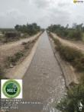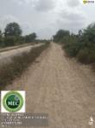 | 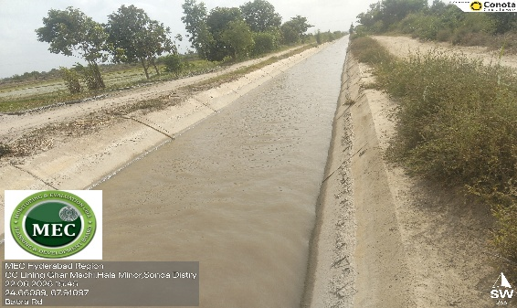
6. |  | 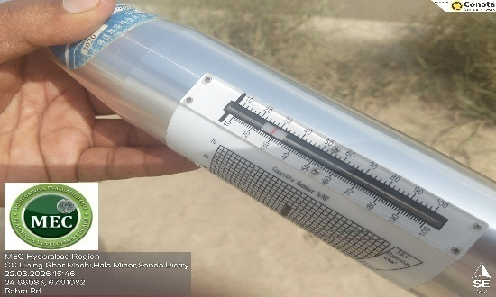 | 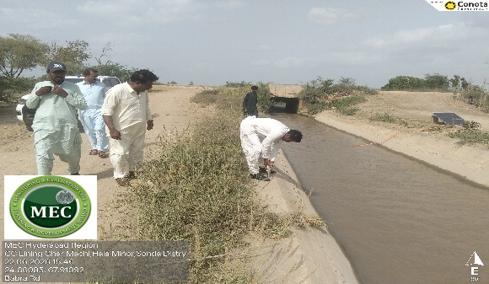
7. |  | 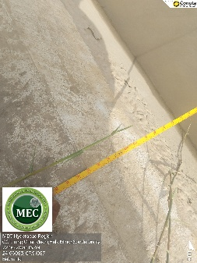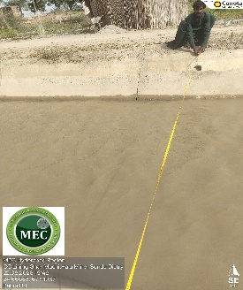 | 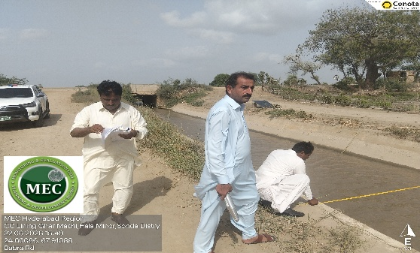
8. |  | 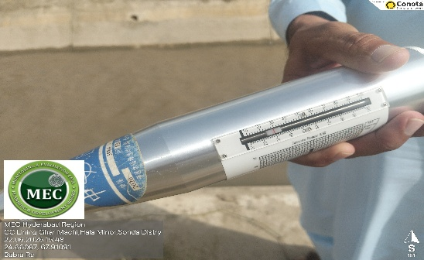  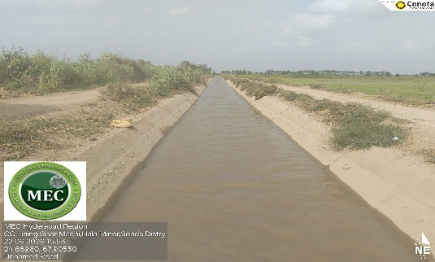 | 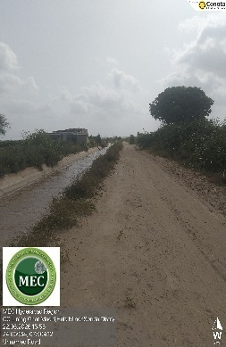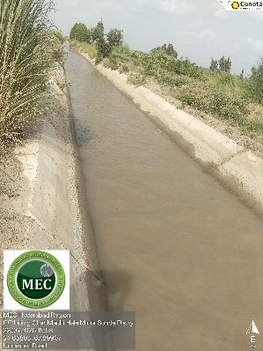  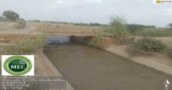
9. | CC Lining Distributary 00RD to 35.00RDs:  The Monitoring and Evaluation Committee (MEC) team conducted a site visit to inspect the cement concrete (CC) lining work at the Sonda Distributary, covering a total completed length of 35 Reduced Distances (RDs). Due to the Inspection Path (IP) and Non-Inspection Path (NIP) being entirely non-motorable, the team was forced to inspect random spots along the channel. Quality assurance via Non-Destructive Testing (NDT) was performed at RD 01, RD 08, and RD 16 using a Schmidt hammer, which confirmed that the compressive strength of the CC lining complies with the project's specified design strength, yielding a "fair" overall quality rating. Additionally, minor repairs to the regulator at RD 00 of the Sonda Distributary (located at the X19.5 RD Link Canal) were found completed. However, critical deficiencies were observed as earthwork, compaction, and leveling on both the IP and NIP banks have not been carried out, and required de-weeding and jungle clearance remain uninitiated on several RDs. Addressing these gaps, the Executing Agency (EA) briefed the MEC team that the contractor has currently only received financial payments for the core CC lining work; consequently, the construction of various inlet structures across different RDs represents additional physical progress that currently exceeds the recorded financial disbursement. | 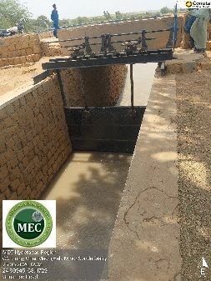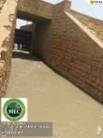 | 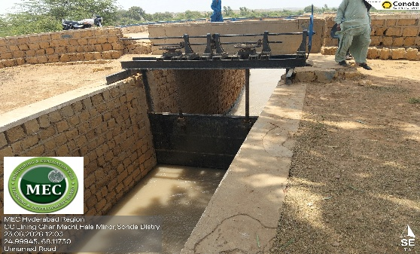
10. |  | 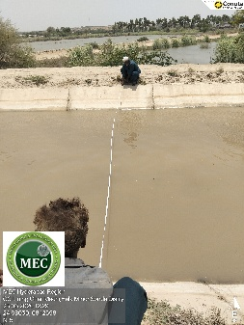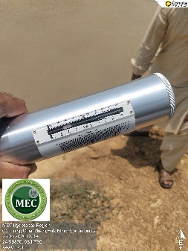 | 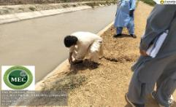
11. |  | 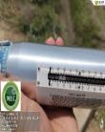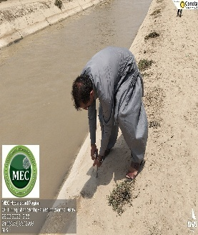 | 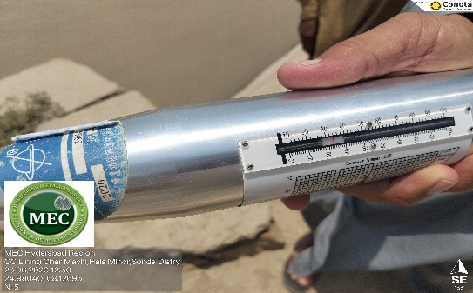
12. |  | 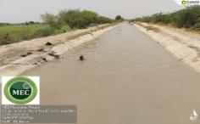  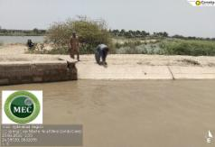 | 