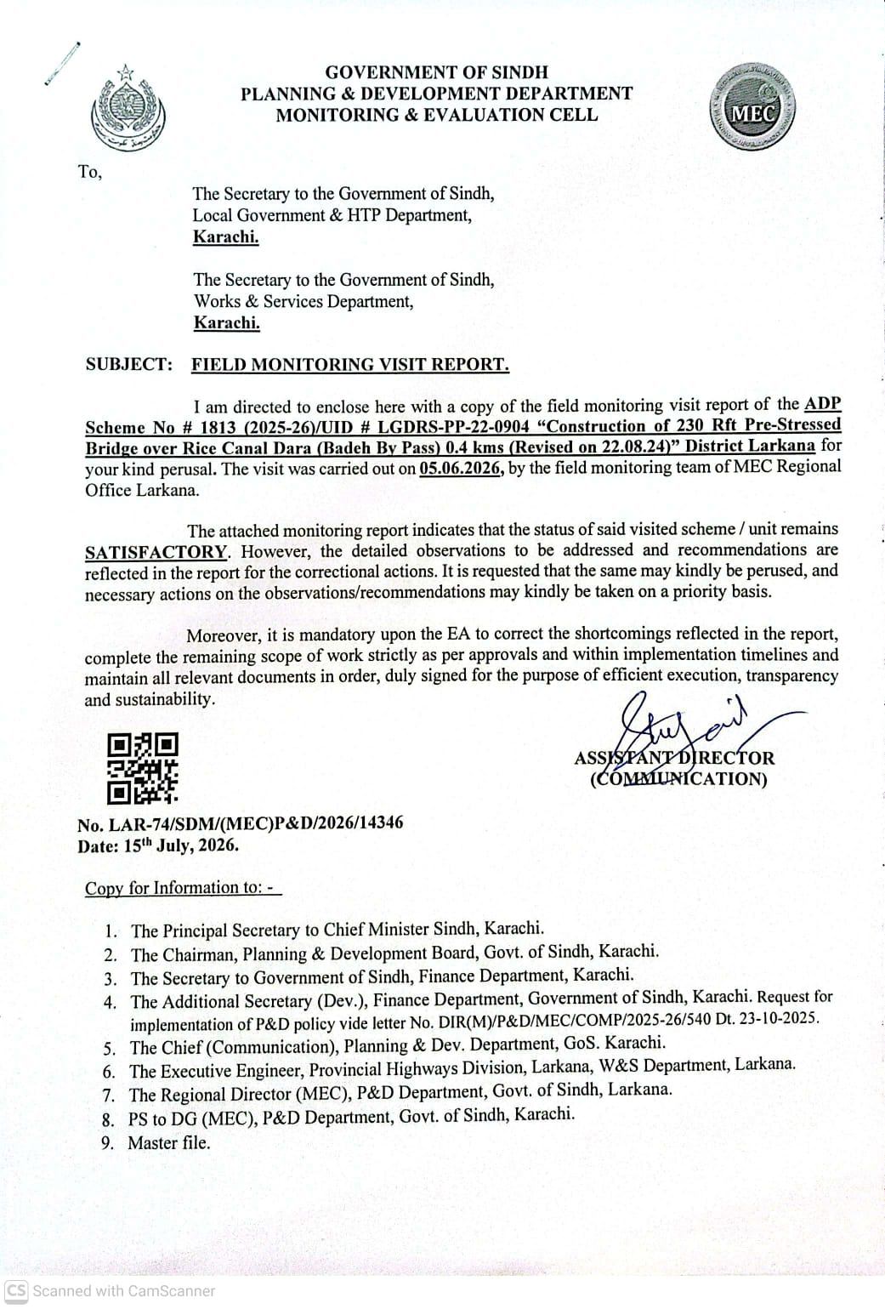
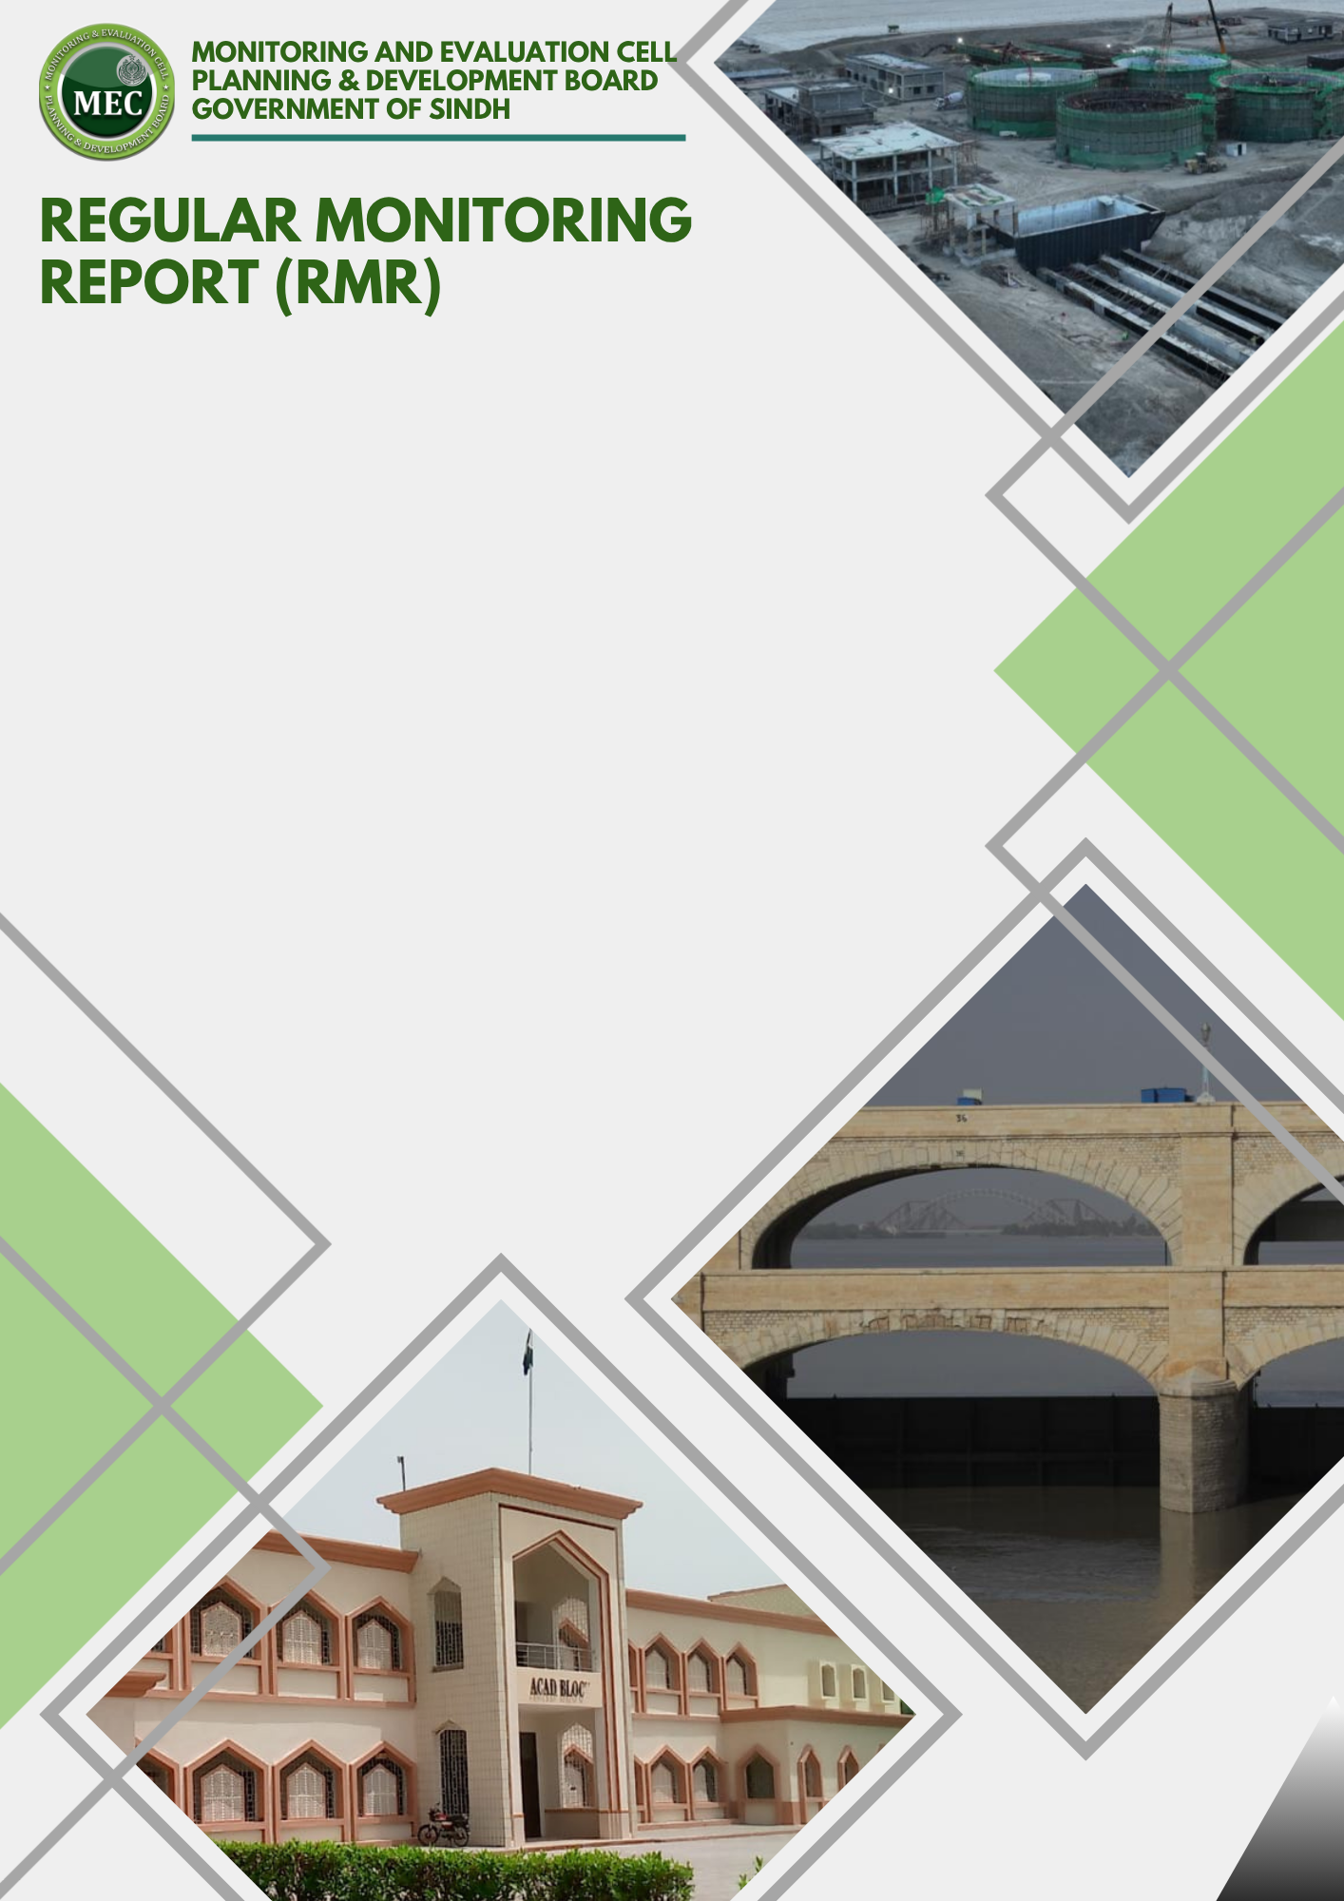
MEC Region | : | LARKANA
ADP # | : | 1813/2025-26
Estimated Cost | : | 199.948
Sub Sector | : | Road
Admin Department | : | Local Government Department
Executing Agency | : | Executive Engineer, Provincial Highway Division Larkana

Physical Progress % | : | 100%
Financial Progress % | : | 100%
Earned Value | : | 199.948
SPI | : | 1.00
CPI | : | 1.00

PROGRESS ASSESSMENT

REGULAR MONITORING REPORT (RMR)
INFRASTRUCTURE SECTOR
Sub-Sector: Roads |  |  |  |  |  |  |  |  |  | Type of Scheme: Independent
PART - A: PROJECT PROFILE
1. | Scheme / Unit Information
 |  |  | ADP / UID No. |  |  | ADP No. 1813/2025-26 (UID # LGDRS PP-22 0904)
 |  |  | Name of the Project / QRC |  |  | Construction of 230 Rft Pre-Stressed Bridge over Rice Canal Dara (Badeh Bypass) 0.40 Kms (Revised on 22.08.24). |  |  |  |  |  |  |  |  |  |  |  |  |  | 
 |  |  | Visit Location of the Project |  |  | UC/Town |  | Dokri |  |  |  |  |  |  |  | District |  | Larkana
 |  |  | GPS Location Coordinates |  |  | Lat (N): |  | 27.33725 |  |  |  |  |  |  |  | Long (E): |  | 68.03336
 |  |  | Administrative Department |  |  | LOCAL GOVERNMENT DEPARTMENT, GOVERNMENT OF SINDH
 |  |  | Executing Agency |  |  | PROVINCIAL HIGHWAYS DIVISION, LARKANO, W&S DEPARTMENT
 |  |  | Consultant / Design Engineer |  |  | --
 |  |  | Contractor (s) |  |  | M/s. Nabi Builders & Co.
 |  |  | Revision of PC-I Status |  |  | Revised One Time |  |  |  |  |  | Date of Revision (if any) |  |  |  |  |  | 20-11-2024
 | j. |  | Project Objectives (as per PC-I) |  |  | The main objective of the proposed scheme connects Badeh Bypass and Dokri Nasirabad road. This scheme would also connect various villages along both sides of road. The proposed scheme would benefit large number of populations along both sides of road to transport agricultural products to the markets of Badeh and Dokri. In short, it would give multi-dimensional benefits to the public of the area.
2. |  | Procurement Process Details
 |  | a. |  | Date of A.A. Issued | Original: 16-02-2023  Revised: 20-11-2024 |  |  |  |  |  | b. |  |  |  | Procurement Method |  |  |  | Manual
 |  | c. |  | No. of bidders/Pre-Qualified Contractors | Two |  |  |  |  |  | d. |  |  |  | Date of LOA/Work award |  |  |  | --
 |  | e. |  | Reason for delay (A.A vs LOA) | --
 |  | f. |  | Final Bid Amount | -- |  |  |  |  |  | g. |  |  |  | Variance of Bid Amount against PC-I Cost (%) |  |  |  | --
2. | Monitoring Visit History
 |  |  | Last Visit Date (if any) |  |  | 22-01-2026 |  |  |  |  |  |  |  | Last Visit’s Assessment Status |  |  |  | Satisfactory
 |  |  | Planned Visit Date |  |  | 05-06-2026 |  |  |  |  |  |  |  | Current Visit Date |  |  |  | 03-06-2026AC
 |  |  | Reason for Delay (if any) |  |  | --
 |  |  | A.D/E.A. Officer(s) on Site |  |  | Name | Mr. Asfaque Solangi  Mr. Salim |  |  |  |  |  |  |  |  | Designation |  | Assistant Engineer  Sub Engineer
 |  |  | MEC Team During the Visit |  |  | Name | Engr Umair Aslam |  |  |  |  |  |  |  |  | Designation |  | MEO – Roads
 |  |  | Any local Community member interviewed/engaged for visit |  |  | Name | -- |  |  |  |  |  |  |  |  | Occupation |  | --
3. | Financial Progress (FP). (Amounts in PKR, million)
 |  |  | Funding Agency Share (%) |  |  | GoS Share |  |  | 100% |  |  |  | GoP Share |  |  |  | -- | FPA Share |  |  | --
 |  |  | Approved Cost of the Project (M) |  |  | Capital |  |  | 109.986 |  |  |  | Revenue |  |  |  | -- | Total |  |  | 109.986
 |  |  | Revised Cost of the Project  (if any) |  |  | Capital |  |  | 199.948 |  |  |  | Revenue |  |  |  | -- | Total |  |  | 199.948
 |  |  | Unit Cost of the Project  (if applicable) |  |  | Capital |  |  | -- |  |  |  | Revenue |  |  |  | -- | Total |  |  | --
 |  |  | Financial Progress  (Up to 5 Years) of Scheme |  |  | Up to  2021-22 |  |  | 2022-23 |  |  |  | 2023-24 |  |  |  | 2024 -25 | 2025 -26 |  |  | TOTAL
 |  |  | - Allocation |  |  | -- |  |  | -- |  |  |  | -- |  |  |  | 127.976 | 71.970 |  |  | 199.946
 |  |  | - Releases (as per F.D. Data) |  |  | -- |  |  | -- |  |  |  | -- |  |  |  | 127.976 | 71.970 |  |  | 199.946
 |  |  | - Expenditure (as per F.D/E.A Data) |  |  | -- |  |  | -- |  |  |  | -- |  |  |  | 127.976 | 71.970 |  |  | 199.946
 |  |  | Overall Financial Progress in % |  |  | 100% |  |  |  |  |  |  | FP variance vs PP |  |  |  |  | --

4. | Financial/Physical Progress Graph. (Amounts in PKR, million)

PART - B: PROJECT ANALYSIS
1. | Quantitative Breakdown (Provided by EA and verified by MEO)
S# | Domain | Activity / Material | Name of the Test | Required | Achieved | GAP  (if any) | Unit | Standard | Remarks
 | Road | Earth Work | Excavation |  |  |  | Cft |  | NO TEST REPORT PROVIDED TO MEC TEAM
 | Road | Earth Work | Back Fill |  |  |  | Cft |  | NO TEST REPORT PROVIDED TO MEC TEAM
 | Road | Compaction | FDT | 95% |  |  | % | AASHTO | NO TEST REPORT PROVIDED TO MEC TEAM
 | Road | Soil | Sieve Analysis |  |  |  |  | ASTM C- 136 | NO TEST REPORT PROVIDED TO MEC TEAM
 | Road | Soil | Sp. Gravity | 2.6 > 2.7 |  |  |  | ASTM C-128 | NO TEST REPORT PROVIDED TO MEC TEAM
 | Road | Soil | Water Absorption | 3% |  |  | % | BS 812-2 | NO TEST REPORT PROVIDED TO MEC TEAM
 | Road | Cement Concrete | Slump Test | 80 > 150 |  |  | Mm | ASTM C 143 | NO TEST REPORT PROVIDED TO MEC TEAM
 | Road | Cement Concrete | Temperature | 75 > 95 |  |  | ºF | ACI 305 | NO TEST REPORT PROVIDED TO MEC TEAM
 | Road | Cement Concrete | Water-Cement Ratio | 0.45 (Max) |  |  |  |  | NO TEST REPORT PROVIDED TO MEC TEAM
 | Road | Steel Rebar Gr-40 | Tensile Test | 40000 |  |  | Psi | ASTM A-615 | NO TEST REPORT PROVIDED TO MEC TEAM
 | Road | Steel Rebar Gr-60 | Tensile Test | 60000 |  |  | Psi | ASTM A-615 | NO TEST REPORT PROVIDED TO MEC TEAM
 | Road | NDT | Schmidt Hammer Test | 30 > 50 |  |  | N/mm2 | ASTM C-39 | NO TEST REPORT PROVIDED TO MEC TEAM
 | Road | DT | Core Cutter Test | 25000 |  |  | Psi | ASTM C-40 | NO TEST REPORT PROVIDED TO MEC TEAM
 | Road | DT | Cube Compressive Strength | 25000 |  |  | Psi | ASTM C-41 | NO TEST REPORT PROVIDED TO MEC TEAM
 | Discrepancy in Dimension in / Quality of material against design parameters/Structure |  |  | No
 | Discrepancy/deficiency in quality test against approved PC-I / PEC standards |  |  | No

2. | Project Progress/Component-wise breakdown
 | S# | Major Unit/Component as per PC-I | Physical/Financial Progress
 | S# | Major Unit/Component as per PC-I | Quantity as Per Revised PC-I | Amount as Per Revised PC-I | Quantity as Per T.S. | Amount as Per T.S. | Quantity Recorded in MB | Payment as  per MB | PP (%) | FP (%) | Variance b/w PP & FP
 | PART-A (PRE-STRESSED BRIDG)
 | 1 | Pre-Stressed Bridge | 210 rft | 156.963 | 210 rft | 154.300 | 210 rft | 161.436 | 100% | 100% | --
 | 2 | Add 3% Consultancy Charges | -- | 4.752 | -- | -- | -- | --
 | SUB TOTAL |  |  | 161.672 |  | 154.300 |  | 161.436 | 100% | 100% | --
 | PART-B (CONSTRUCTION)
 | 1 | CG | -- | 0.176 | -- | -- | -- | -- | -- | -- | --
 | 2 | NGC | -- | 0.287 | -- | -- | -- | -- | -- | -- | --
 | 3 | Stone Boulder | -- | 1.043 | -- | -- | -- | -- | -- | -- | --
 | 4 | Earth Work 95-100% | 473485 Cft | 5.426 | 473485 Cft | 11.435 | 674850 cft | 16.300 | 100% | 100% | --
 | 5 | Sand Cushion (River Sand) | 9177 Cft | 0.154 | 9177 Cft | 0.253 | 22356 cft | 0.617 | 100% | 100% | --
 | 6 | S.B.C (Shingle Gravel) | 9177 Cft | 1.026 | 9177 Cft | 1.872 | 16995 cft | 3.466 | 100% | 100% | --
 | 7 | Sub-Base Course | 9177 Cft | 1.343 | 9177 Cft | 2.234 | 8550 Cft | 2.234 | 100% | 100% | --
 | 8 | Brick Edging | 2039 Rft | 0.176 | 2039 Rft | 0.186 | 2039 Rft | 0.186 | 100% | 100% | --
 | 9 | Base Course | 9177 Cft | 1.439 | 9177 Cft | 2.409 | 8550 Cft | 2.409 | 100% | 100% | --
 | 10 | 1st Coat | 18355 Sft | 0.761 | 18355 Sft | 0.825 | 16355 Sft | 0.625 | 100% | 100% | --
 | 11 | 1-1/2" Carpet | 18355 Sft | 2.935 | 18355 Sft | 3.321 | 16355 Sft | 2.721 | 100% | 100% | --
 | 12 | M/Structures + Misc | -- | 22.804 | -- | 1.523 | -- | -- | -- |  | --
 | 13 | Cartage | -- | 5.768 | -- | -- | -- | -- | -- | -- | --
 | 14 | Diff of Material/ Premium | -- | -- | -- | (-) 0.208 | -- | (-) 0.112 | -- | -- | --
 | SUB TOTAL |  |  | 22.807 |  | 22.326 |  | 20.271 | 100% | 100% | --
 | 1 | Contingency | -- | 1.764 | -- | 3.563 | -- | -- | -- | -- | --
 | 2 | SST (5%) | -- | 9.312 | -- | 9.086 | -- | 9.085 | -- | -- | --
 | 3 | Escalation | -- | 4.392 | -- | -- | -- | -- | -- | -- | --
 | GRAND TOTAL |  |  | 199.948 |  | 190.797 |  | 199.948 | 100% | 100% | --

PART - C: QUALITY MANAGEMENT

2. | Sub-Sector Specific Compliance
Stage-Wise Observed Checklist for Roads, Causeways, Schemes Only
Item # |  | Items | As per approved design |  | Item # | Items | As per approved design
1 |  | Clearing & Grubbing | -- |  | 15 | Excavation/Piling | --
2 |  | Removal of Unsuitable Material | -- |  | 16 | Stone Masonry | --
3 |  | Compaction of Natural Ground | -- |  | 17 | Steel | --
4 |  | Preparation of Subgrade/Embankment/Earthwork | -- |  | 18 | Concrete | --
5 |  | Subbase | Through Pit |  | 19 | Curing | --
6 |  | Aggregate Base Course/Base Course | Through Pit |  | 20 | Excavation | --
7 |  | Prime Coat/1st Coat | -- |  | 21 | Laying of Pipe | --
8 |  | Asphaltic Base Course/Binder | -- |  | 22 | Manhole/ Chamber | --
9 |  | Tack Coat/2nd Coat | -- |  | 23 | Back Filling/ Sand Cushion | --
10 |  | Asphaltic Wearing Course/Carpet | Through Pit |  | 24 | Steel | --
11 |  | Brick Edging/Kerb Block | -- |  | 25 | Material storage maintained | --
12 |  | Road Furniture | -- |  | 26 | Housekeeping / Wastage management, Maintained | --
13 |  | Paver/ Walkway / Foot path | -- |  | 27 | Inspection and Testing Reports Provided by E/A | --
14 |  | Installation of Street Light | --

PART - D: DOCUMENTS
1. | Project Approval Documents (Provided by E/A)
Item # |  | Items | Availability  (Yes/No) | Observation
 |  | PC-I / PC-II (If framed) | Yes
 |  | Administrative Approval (AA) | Yes
 |  | Bid Evaluation Report (BER) | Yes
 |  | Work Order Issued to contractor(s) | Yes
 |  | Technical Sanction (TS) | Yes
 |  | Construction / Architecture Drawings | --
 |  | SEPA EIA/EA/NOC | --
 |  | Any Other Document ( _________________ ) | --

2. | Project Implementation Documents (Provided by E/A)
Item # |  | Items | Check  (Yes/No) | Observation
 |  | Implementation Schedule / Annual Work Plan (As per RBM) | Yes
 |  | Measurement Book (MB) | Partial | Abstract of 11th Running Bill
 |  | Soil investigation report | --
 |  | HSE Audit (whether activities have been carried out through HSE audit or not) | --

PART - E: MONITORING ANALYSIS/ASSESSMENTS
1. | Earned Value Analysis
S# | Items | Result | Remarks
 | Planned Value or BCWS | 199.946 | Budgeted Cost of Work Scheduled
 | Earned Value or BCWP | 199.946 | Budgeted Cost of Work Performed
 | Actual Cost of Work Performed (ACWP) | 199.946 | Current Financial Progress
 | Schedule Performance Index (SPI) | 1.00 | SPI = 1.0: The project is exactly on schedule.  SPI > 1.0: The project is ahead of schedule, completing more work than planned.  SPI < 1.0: The project is behind schedule, completing less work than planned.
 | Cost Performance Index (CPI) | 1.00 | CPI > 1.0: The project is under budget and performing efficiently.  CPI = 1.0: The project is exactly on budget.  CPI < 1.0: The project is over budget, spending more than planned.

2. | Risk-Rated Observation Matrix
- | Field Officer | Category | Observation | Risk | Recommendation | Compliance Deadline
- | MEO | Physical | The work of 210 rft prestressed bridge was found completed during the field visit, while work of base course layer for 990 rft of road (Approaches at either of prestressed bridge) was found under progress. | Low | The scheme may formally be closed by submitting the PC-IV of the scheme. | July 2026
- | MEO | Physical | The E.A ensure that the work will be completed including asphalt layer before the end of June 2026, and finally on 24th June 2026 asphalt was carried out on site and geo tagged pictures were shared with the MEC Team. | Low |  | July 2026
- | MEO | Physical | The template and length of road was found in accordance with the PC-I & T/S estimates/measurements. | Low |  | July 2026
- | MEO | Physical | The scheme was physically completed in all respects as ensured by the E.A before June 2026 deadline. | Low |  | July 2026
- | MEO | Financial | Financially, 100% payment after deduction of 5% security deposit / retention money has been paid to the contractor. | Low | The engineers concerned (XEN & A/XEN) were responsible for the payments made to contractors against the work carried out at site w.r.t approved scope in PC-I & T/S. So, if any ambiguity is pointed out at later stages concerned engineers will be held responsible. | --
- | MEO | Financial | Moreover, the payments made to the contractor were found to be in accordance with the work carried out at site w.r.t PC-I & T/S specifications | Low |  | --
- | MEO | EVM | Both the indicators, i.e., SPI & CPI, reflect that the scheme is completed as per schedule and within the budget. | -- | -- | --
- | MEO | PC-I Compliance | -- | -- | -- | --
- | MEO | PM Arrangements | -- | -- | -- | --
- | MEO | General | -- | -- | -- | --
- | MEO | Procurement | -- | -- | -- | --
- | RD | Physical  Financial  EVM  PC-I Compliance  PM Arrangements  General  Procurement | Not visited in person ; as per submission of visiting MEO. | Low | The remaining work of shoulders may be completed on priority basis.  The payments be re-verified before formal closure of the scheme. | By 30th June, 2026.
- | SDM | Physical  Financial  EVM  PC-I Compliance  PM Arrangements  General  Procurement | - The submitted Regular Monitoring Report has been examined through desk review of the report, supporting documents, tables, graphs and available pictorial evidence.  - The reported physical and financial progress is internally consistent and generally corroborated by the photographs showing completion of the bridge structure and subsequent completion of asphalt approaches.  - Earned Value indicators (SPI=1.00 and CPI=1.00) are mathematically correct and indicate completion within the planned schedule and approved budget. However, the report contains several documentation and reporting deficiencies including inconsistent visit dates, typographical errors, missing quality control test reports, incomplete Measurement Book record, absence of HSE audit documentation and lack of supporting construction drawings.  - Significant variations between revised PC-I quantities and Measurement Book quantities should also be adequately justified through approved revisions. | Medium | - Attach complete MB instead of only the running bill abstract.  - Provide all laboratory quality control test reports.  - Submit HSE audit records and safety compliance documentation.  - Provide approved construction drawings and revised quantity justification. | 1 Month

3. | FINAL ASSESSMENT OF THE PROJECT / SCHEME / UNIT
 | MEO/SMEO | RD | SDM
 | SATISFACTORY | Satisfactory | Satisfactory

PART - F: PICTORIAL OBSERVATIONS
S# | Specific Observations | Pictures
1. | 210 rft Pre-Stressed Bridge | 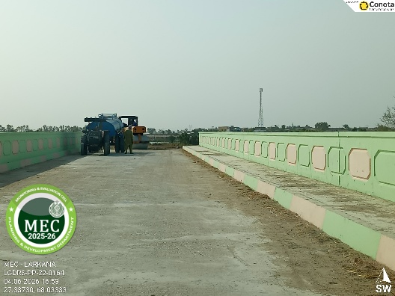 | 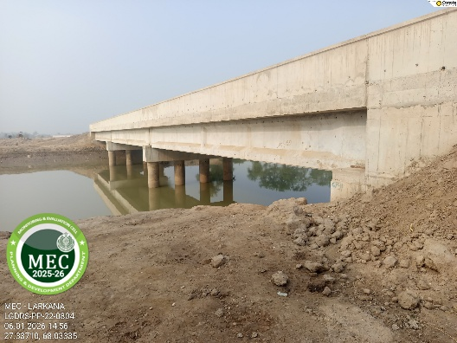
2. | Work of base Course in Progress (Up Stream) | 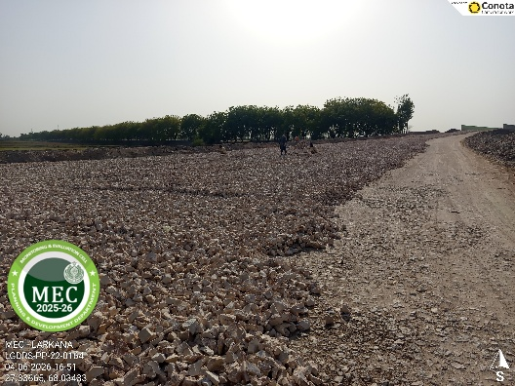 | 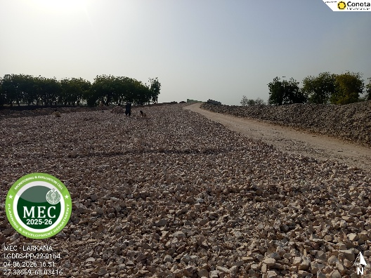
3. | Work of base Course in Progress (Down Stream) | 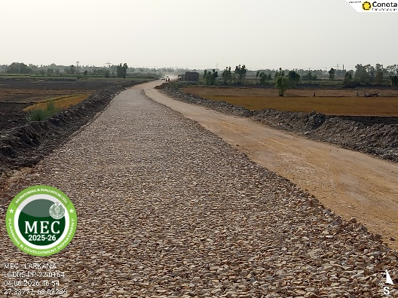 | 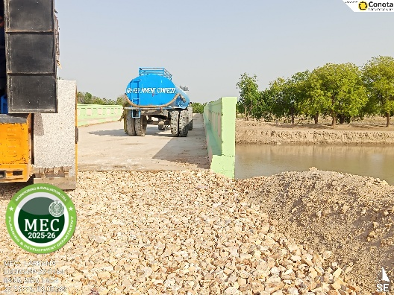
4. | Work of base Course in Progress (Down Stream) | 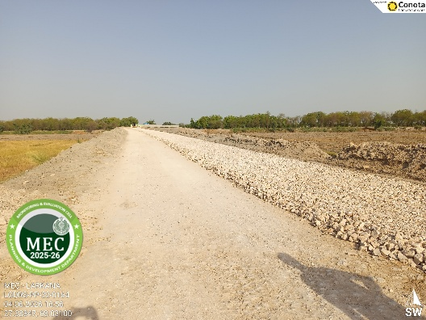 | 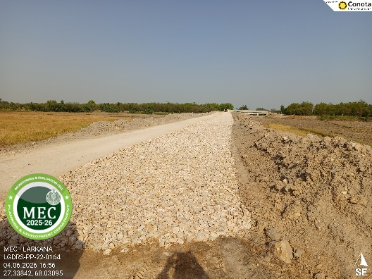
5. | Asphalt Done – Geo Tagged Picture Shared by E.A | 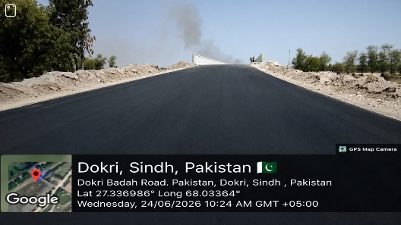 | 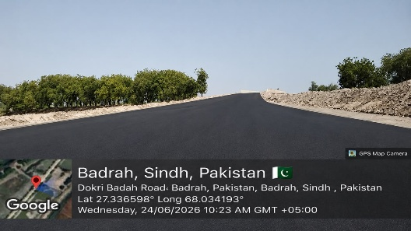
6. | Asphalt Done – Geo Tagged Picture Shared by E.A | 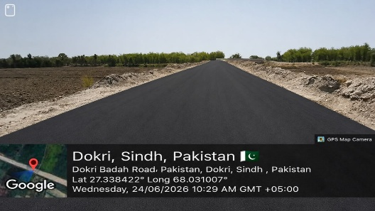 | 